Web-4-All Administrator/User Manual

Main Window:
Web-4-All’s Main Window presents users with the following two options: “Edit preferences…” and “Cancel configuration”. To enable the “Edit preferences…” button, a client’s Smart Card must first be inserted into the card reader. Selecting “Edit preferences…” launches the Web-4-All Preference Wizard. Selecting “Cancel configuration” restores all applications to their original default settings. If Web-4-All’s default settings have not been changed, then selecting the “Cancel configuration” button will have no apparent effect.

(Note: All Web-4-All options can be accessed using a keyboard or pointing device such as a mouse, trackball, etc. The Tab key allows keyboard users to cycle through the various options, the Spacebar enables users to make a selection, and the Up and Down arrow keys are used to scroll through multiple menu selections. Alternately, depressing the Alt key and any letter underscored on a dialog screen will toggle that particular option on or off.)



Preferred Language:
The Preferred Language dialog presents clients with two radio button options, allowing users to select either English or French as their default language. The default setting is English, but selecting Français automatically converts the Preference Wizard screen (and all subsequent dialogs) into French.

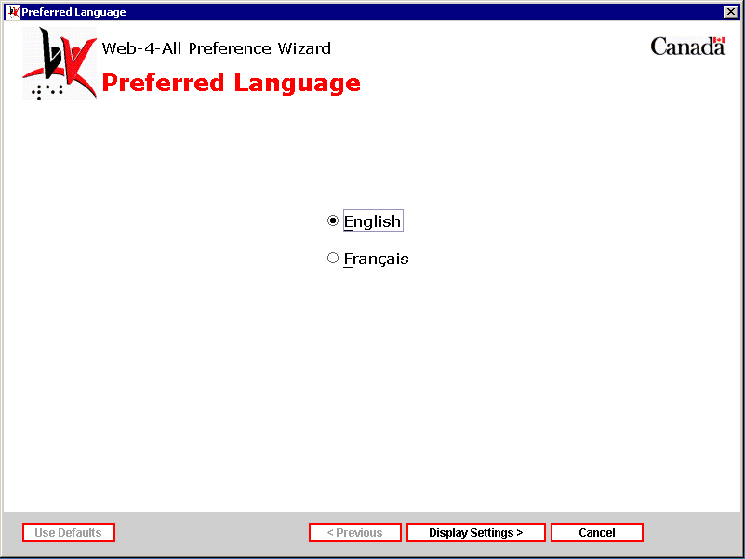

After choosing a language preference, select “Display Settings” to advance to the Display Preferences dialog or “Cancel” to exit the setup altogether.

Display Preferences:
The Display Preferences dialog enables users to modify the presentation of onscreen Web content and make it more accessible to individuals with special needs. The following checkbox options are associated with this dialog:

- “Make text and the cursor easier to see.” – The first checkbox option allows users with low vision to make the onscreen display easier to see either through the use of a screen magnifier or by increasing font size, improving colour contrast, etc.

- “Highlight text and read it to me.” – Checkbox two enables clients to have text highlighted and then read to them via a speech synthesizer.

- “Read the screen to me.” – The third checkbox allows users to set specific preferences for Web-4-All’s default screen reader.

- “Let me use a Braille display.” – Selecting this checkbox enables users to have online content converted into Braille.

- “Show visual alerts.” – This last checkbox allows those with a hearing impairment to have all computer audio sounds converted into visual signals and/or captions.

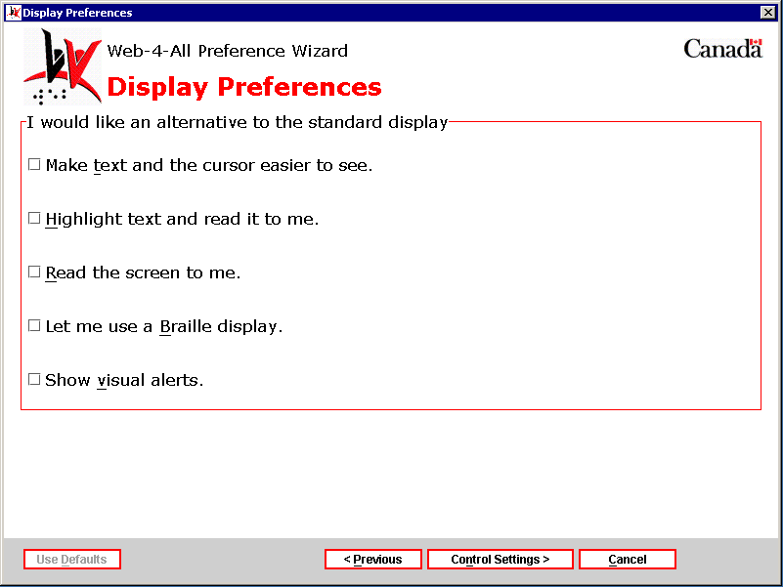

After selecting the appropriate Display Preference checkboxes, choose “Control Settings” to advance to the Control Preferences page. To return to the language preferences dialog, select “Previous”. To exit Web-4-All, select “Cancel”.

Control Preferences:
The Control Preferences dialog is separated into three sections: “I would like an alternative to the standard keyboard”, “I would like an alternative to the standard mouse”, and “I would like an alternative to the standard controls”. Each section is described separately below:

I would like an alternative to the standard keyboard
This section is designed primarily for clients who have difficulty selecting individual keys on a standard keyboard. Users have the option of modifying a standard keyboard or replacing it altogether with an alternative.

- Enhance the standard keyboard: This first checkbox helps to make a standard computer keyboard easier to use.
- Use an onscreen keyboard: The second checkbox enables clients to replace the standard keyboard with an onscreen keyboard display.
- Use an alternative keyboard: The third checkbox allows users to create an alternative to the standard alphanumeric keyboard device.

I would like an alternative to the standard mouse
Two options are associated with this section, which is designed to assist clients who have difficulty using a mouse (i.e. seniors with a tremor, people with poor motor control, etc.)

- Control the mouse pointer with keyboard: The first option enables users to control the mouse pointer using the keyboard.
- Use a mouse alternative: The second checkbox allows users to replace the mouse with an alternate pointing device (i.e. trackball, etc.)

I would like an alternative to the standard controls
The third section features two checkbox options that enable clients to control the Web-4-All system using the following non-standard controls:

- Use voice recognition: This checkbox enables users to activate and control the computer through spoken commands.
- Use coded input (i.e. Morse, chordic, quartering, or eight cell): This selection allows users to control the computer via coded input methods such as Morse code, quartering of the keyboard, etc.
- Use word prediction: This option helps those with mobility and cognitive issues type faster and more accurately by generating a list of words based on letters that the user has entered. For example, if a user types the letters “ele” with word prediction turned on, the most frequently used words matching those letters within the context of the sentence will appear in a selectable list. In the example above the list of words might include “elect”, “electricity”, “elect”, “element” and so on. If the user then adds the letter “p” to the entry (i.e. “elep”) then the current list might be replaced by the word “elephant”.

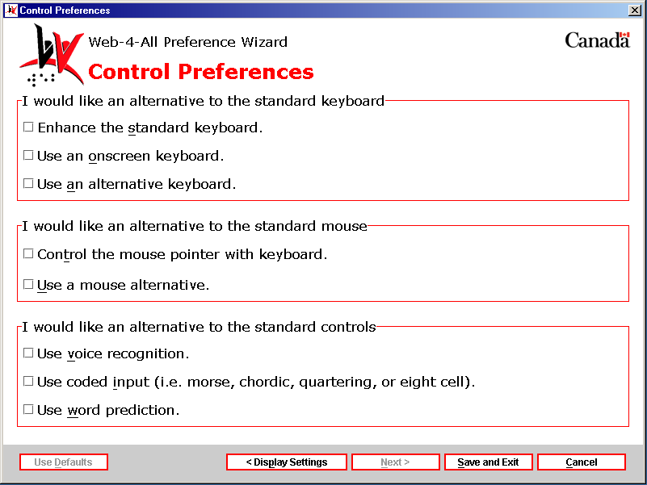

(Note: Some clients may have multiple disabilities and require a combination of assistive technologies. Web-4-All allows users to select unlimited combinations of all available assistive technologies. There are, however, instances where certain third party programs will not function in conjunction with each other. In an effort to accommodate as many individuals as possible, Web-4-All will not restrict user selections. Within this document, however, we will attempt to identify all potential conflicts.)

After selecting all applicable checkboxes for Control Preferences, choose “Save and Exit”. This will automatically launch, in sequential order, all Display Preference settings followed by all Control Preference dialogs chosen by the user.

Buttons:
At the base of most Web-4-All dialog screen are the following buttons: “Use Defaults”, “Previous”, “Next”, and “Cancel”. The “Previous” and “Next” buttons allow users to navigate forward and backward through Web-4-All’s dialog screens. They remain “greyed out” (i.e. inactive) until a selection has been made and a subsequent (or previous) screen is available. Making a selection also enables the “Use Defaults” button. Selecting “Use Defaults” restores a dialog to its original settings. “Cancel” remains active on each dialog page and allows users to exit the Web-4-All setup process entirely at any given stage. An additional button, “Save and Exit”, replaces “Next” when the final dialog screen within a section is reached. “Save and Exit” stores all user preference settings onto their Smart Card, closes down the Preference Wizard, and then automatically launches the Web-4-All Favourites Web site along with all selected applications (i.e. Screen Readers, Alternative Keyboards, specific Web Browsers, etc.)

Display Preference setting dialogs

1) “Make text and the cursor easier to see.” – Enabling this checkbox and then selecting “Next” launches the Screen Enhancement Settings dialog enabling users to set Text, Cursor, and Screen Tracking preferences. Note: When this option is activated, some screen readers may not function.

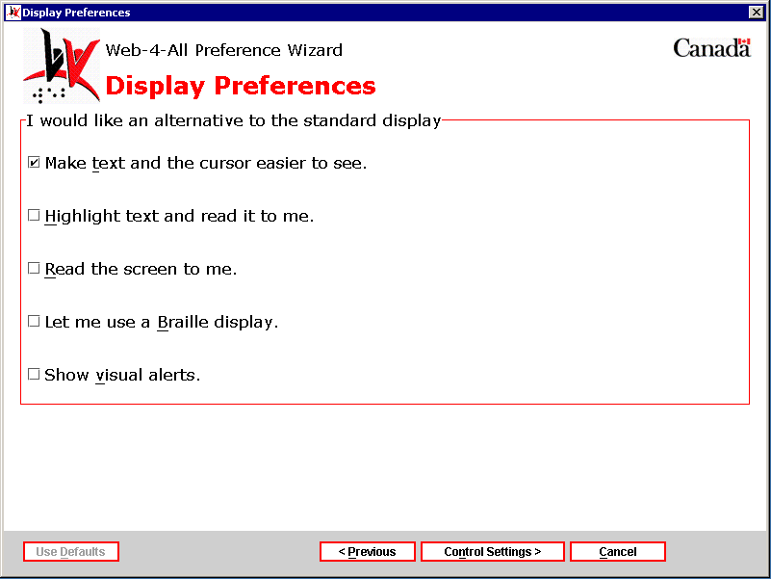

Screen Enhancement Settings dialog (page 1) – The Screen Enhancement Settings dialog is divided into two sections: Text Preferences and a Preview window.

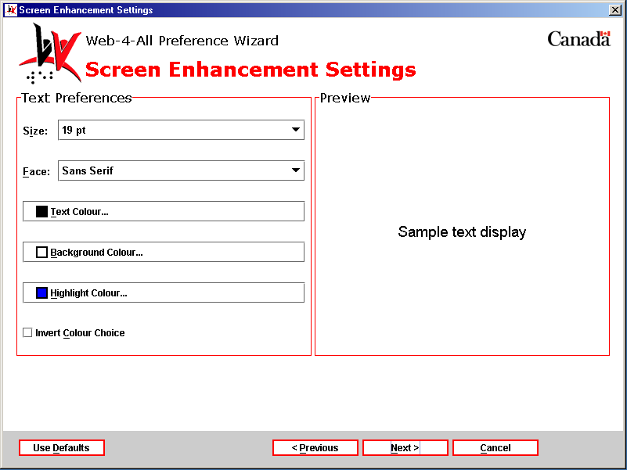

Text Preferences – This section enables clients with low vision to change font size, font face, and text/background/highlight colours to meet their particular needs. Users are also able to view their selections in a Preview window.

- Size: This pull-down menu displays font sizes ranging from 10 to 30 points (pt) with increments of 1 pt between each value (19 pt is the default). Point size is derived from typesetting standards used by traditional printing presses. In general terms, point size is a relative measure of the size of a font. In Web pages, however, point size can vary from computer to computer. A 12-point font, for example, can be larger on one computer monitor compared to another.

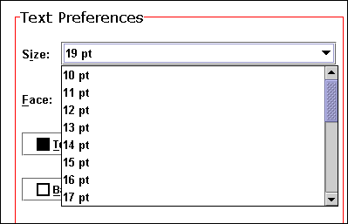

- Face: The font Face setting offers clients five choices with regard to type face: Serif, Sans Serif, Monospaced, Cursive, and Fantasy. Because many specialized fonts can be difficult for users with poor vision to read and are only available if installed locally on a computer system, Web-4-All limits font Face to these five selections. Serif type features small decorative “finishing strokes” or fillips to the basic form of a character. Sans Serif is plain typeface, and does not include these fillips. Monospacing ensures that fonts maintain the same width for each character as opposed to proportional spacing which allots greater width for characters such as “w” and less space for letters such as “i” or “l”. Cursive font styles emulate human handwriting. In terms of Web-4-All, it represents a generic font-family category. Fantasy is also a generic font-family category comprised of decorative-type fonts.

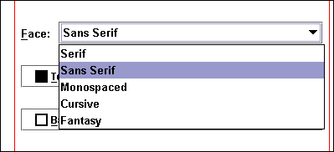

- Text Colour: The default colour for text is black against a white background. Some low vision users, however, find that other colour combinations are easier to see. To change text colour, click on the black swatch to launch Web-4-All’s Colour Picker. The Swatches Palette contains 310 Web-safe colours. User selections are stored separately under “Recent:” for easy access. A preview of the chosen text colour is displayed against grey and white backgrounds and is also presented as a background colour with text displayed in black. RGB values (described below) are also displayed when the pointer is placed over a particular colour. When the HSB tab is selected, clients choose text colours using either a slider, which adjusts Hue, Saturation, and Brightness levels or by entering whole numbers in the value display windows. The RGB tab enables users to choose their text colour by adjusting Red, Green, and Blue sliders or by entering whole numbers in the value display windows.

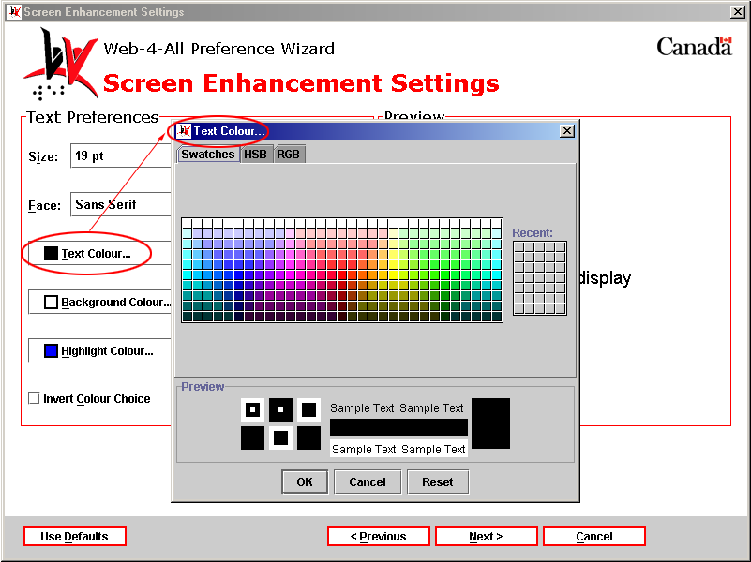

- Background Colour: The default background colour is white. To change the background colour, click on the white swatch to launch Web-4-All’s Colour Picker. (For a detailed description of Web-4-All’s Colour Picker, see Text Colour above.)

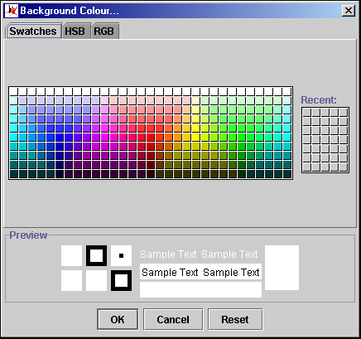

- Highlight Colour: Typically, highlight colour is used to indicate that a portion of text links to additional information. It is most commonly used in mouse rollovers (e.g. the text changes colour when a mouse or other pointing device moves over it to indicate that the highlighted word or words also serve as a link).

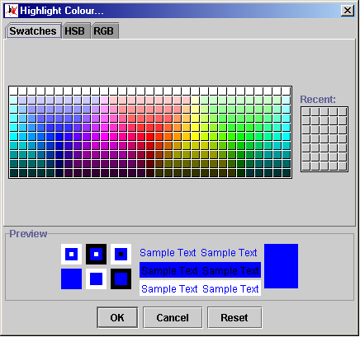

- Invert Colour Choice: This checkbox enables users to view their selections for text and background colours transposed.

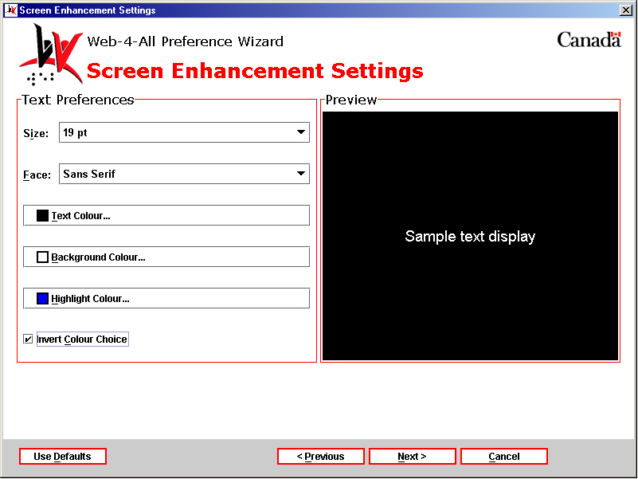

- Preview: As noted earlier, all changes made to Font Size, Face, and Colour in the Text Preferences section are displayed in the Preview window as illustrated below.

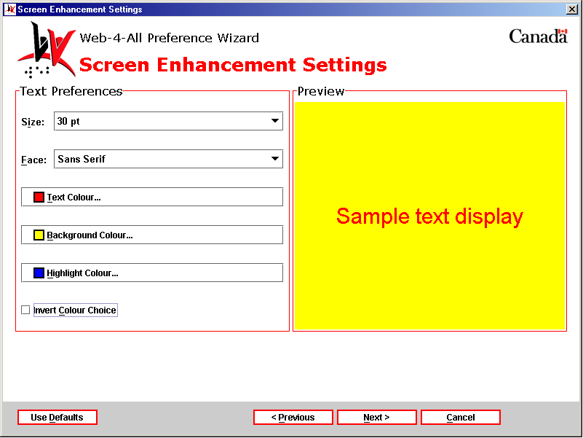

Screen Enhancement Settings dialog (page 2) – The second Screen Enhancement Settings dialog is also divided into two sections: Cursor Preferences and Screen Magnification.

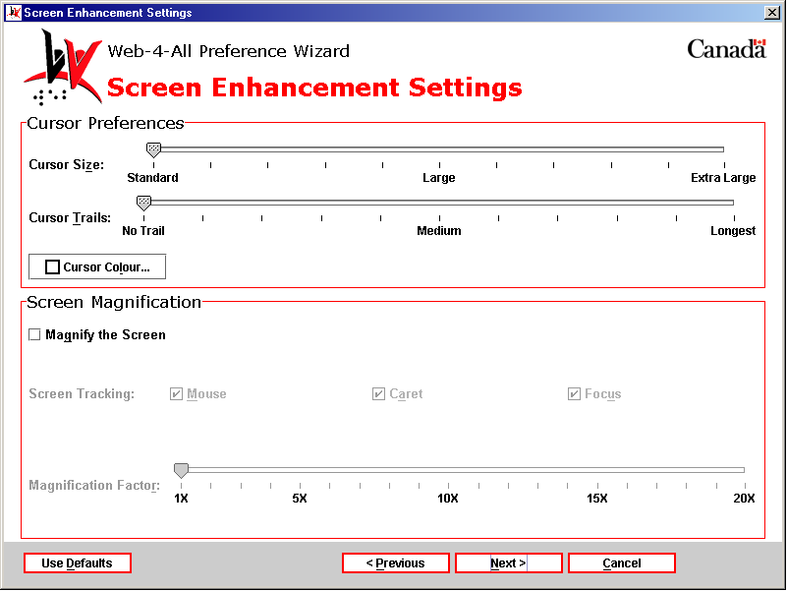

Cursor Preferences – This section enables clients to enhance the visibility of the cursor (the cursor indicates where the next character will be placed) by altering its size, adding a cursor trail, or changing its colour. Because of the way the Windows Operating System implements these changes, however, modifications to the cursor cannot be displayed in a preview window. The system must be rebooted in order to view changes to the cursor.

- Cursor Size: Cursor size is adjusted using a slider with values ranging from Standard (the default) to Large and Extra Large. The slider’s pointer snaps to increments in between marked values.
- Cursor Trails: Cursor trails can be useful to some users with a visual impairment by helping them track the movement of their pointing device. As with Cursor Size, this option is controlled using a slider.

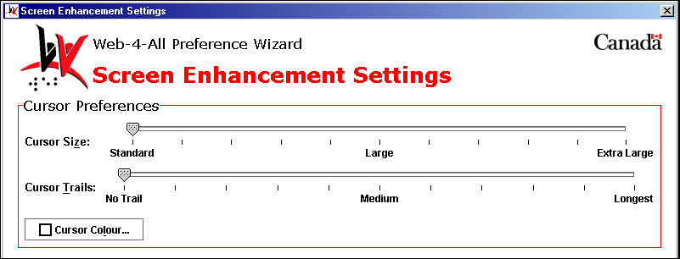

- Cursor Colour: When this checkbox is select a colour palette identical to the one described for text, background, and highlight is launched.

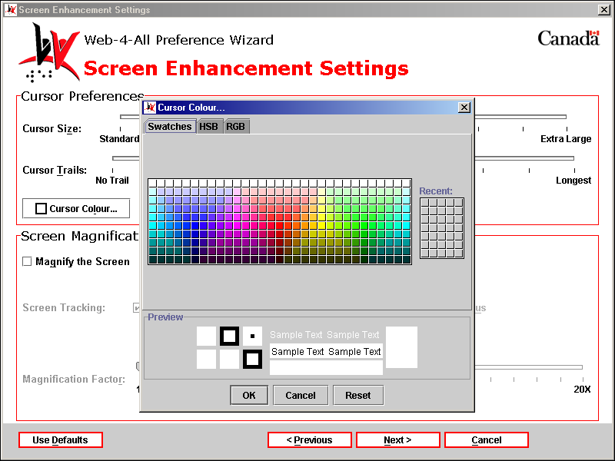

Screen Magnification – Selecting the “Magnify the Screen” checkbox enables the Screen Tracking checkboxes and the Magnification Factor slider.

- Screen Tracking: This is only applicable when a Screen Magnifier is installed on a Web-4-All workstation. The three checkbox options allow users to control which portion of the screen is magnified by positioning the Mouse pointer, the Caret (i.e. the flashing insertion point), or Focus (i.e. using the Tab key to advance through a Web page). Note: All three checkboxes can be activated at the same time allowing clients to use whichever method is most convenient at any given time.
- Magnification Factor: This slider enables users to control the extent to which a portion of the screen is enlarged. In the example below, the screen would be magnified five times its standard size. Values for the magnification slider range from one to 20 times.

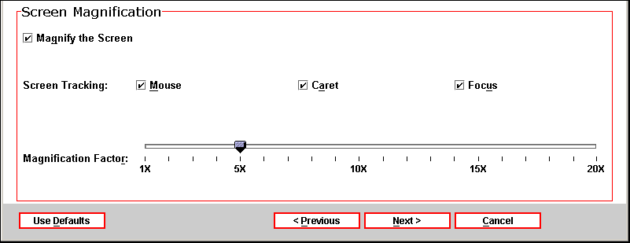

Once selections have been completed on this dialog screen, select “Next” to advance to the Screen Enhancement Applications dialog.

Third Party Applications: The Screen Enhancement Applications dialog allows users to establish a third party program as their default screen enhancer. Each time a client’s Smart Card is inserted into a Web-4-All Card Reader, default applications selected by the user will also be launched. Because availability of third party applications varies from workstation to workstation, users can create a list of default screen enhancement applications and organize them in order of preference. For example, if a user’s initial selection is unavailable, Web-4-All will search for, and launch, their second choice, and so on. Up to five third party applications can be selected. Users also have the option of accessing third party preference settings via this dialog.

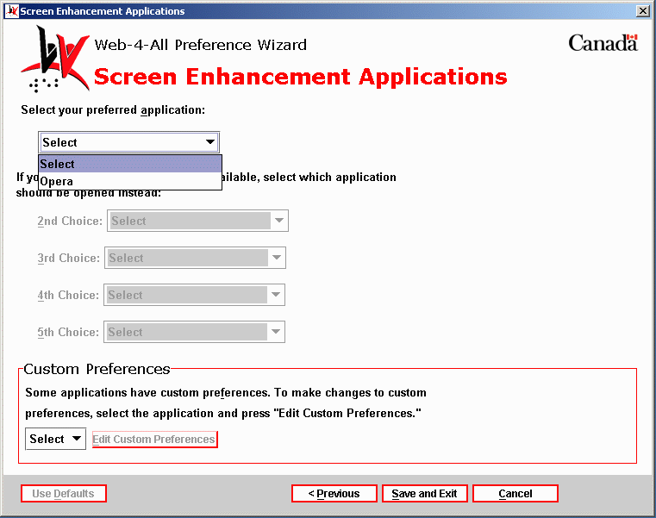

- Custom Preferences – This section enables users to configure the preference settings of any third party application listed on Web-4-All. Use the pull-down menu to choose an application and then select Edit Custom Preferences to access that particular application’s preference settings. These settings are stored on an individual’s Smart Card so that each time Web-4-All launches a favourite third party application those preferences will be automatically loaded along with the program.

2) “Highlight text and read it to me.” – This option is especially useful to individuals with cognitive impairments and to those with low vision. It allows clients to create default settings for having text highlighted and read aloud via a speech synthesizer. Enabling this checkbox and selecting “Next” launches the Text Reading Highlight Settings dialog. Note: When this option is selected some screen magnifiers and on-screen keyboards may not function.

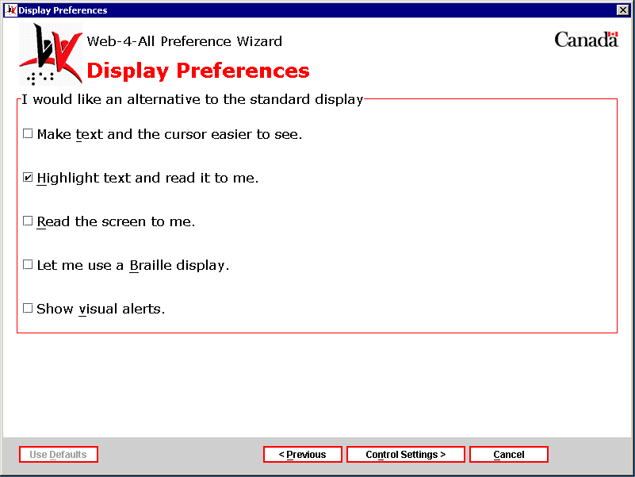

Text Reading Highlight Settings dialog – The Text Reading Highlight Settings dialog is divided into the following three sections: Voice Preferences, Speech Preferences, and Text Highlight Preferences. Each section is described in detail below.

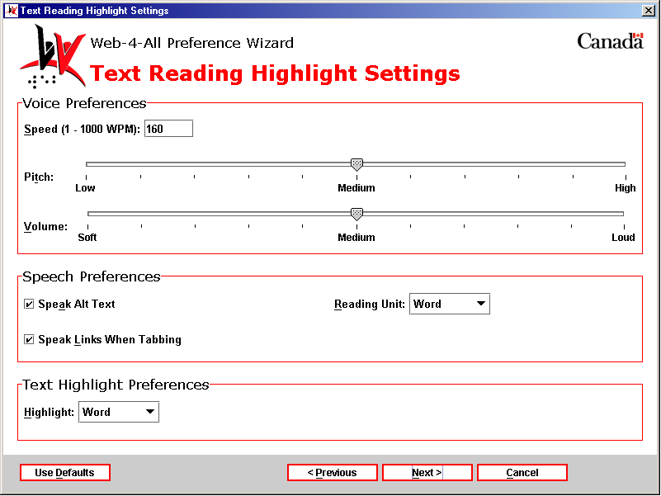

Voice Preferences – In addition to setting the speed at which text will be read, users can also select voice pitch and voice volume.

- Speed: This option allows clients to control the speed at which the voice synthesizer reads highlighted text. Users can enter a value ranging from 1 to 1000 words per minute (WPM) but the optimum range for most people is between 80 and 240 WPM. The default setting in Web-4-All is 160 WPM.
- Pitch: The text reader’s voice Pitch is controlled by a sliding scale, which allows users to either lower (i.e. deepen) voice pitch or make it higher. The slider has three established settings: Low, Medium (the default), and High. There are four steps between Low and Medium and Medium and High. The slider’s pointer snaps to increments between marked values.
- Volume: The sliding scale for voice Volume allows clients with diminished or sensitive hearing levels to adjust the volume accordingly. Web-4-All offers three volume settings: Soft, Medium (the default), and Loud. As with Pitch, there are four steps between Low and Medium and Medium and High. The slider’s pointer snaps to increments between marked values.

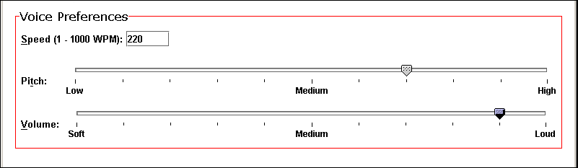

Speech Preferences – This section enables clients to have the text reader identify and speak alternate text for images and hypertext links – two common elements found in most Web pages.

- Speak Alt Text: Many users find it helpful to hear a description of complex images. Individuals with a visual impairment will obviously benefit by having images embedded in Web pages described to them. Leave this checkbox checked to have alternate text read aloud (this is the default). To have the screen reader skip over Alt text, uncheck the box.
- Speak Links When Tabbing: A blind user may be unaware that a link exists within a Web document without some type of auditory signal. When this checkbox is selected (the default), the word “link” is repeated each time the user encounters a hyperlink while tabbing through a document. To have the text reader ignore hyperlinks when the Tab key is used, uncheck the box.
- Reading Unit: This pull-down menu enables users to have text highlighted and read aloud word-by-word, sentence-by-sentence, line-by-line, or paragraph-by-paragraph.

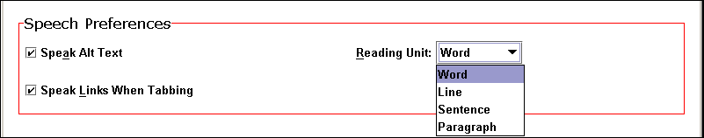

Text Highlight Preferences – The Highlight pull-down menu offers the following options:

- Word: When this option is selected each individual word spoken by the screen reader is highlighted automatically. (Highlight Word is Web-4-All’s default.)
- Line: When Line is selected, each line on a Web page will be automatically highlighted and then read aloud.
- Sentence: When this option is selected, each complete sentence appearing in a Web document will be highlighted as it is read aloud by the screen reader.
- Highlight Paragraph: When Highlight Paragraph is selected, each paragraph within a Web document is highlighted while the screen reader reads it.

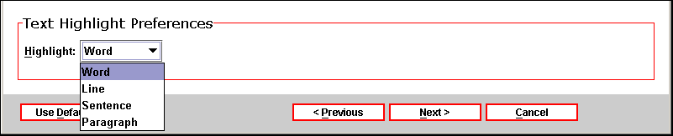

Once all selections have been made, select “Next” to advance to the Text Reading with Highlight Applications dialog.

Third Party Applications: The Text Reading with Highlight Applications dialog allows users to establish a third party program as their default screen enhancer. Each time a client’s Smart Card is inserted into a Web-4-All Card Reader, default applications selected by the user will also be launched. Because availability of third party applications varies from workstation to workstation, users can create a list of default screen enhancement applications and organize them in order of preference. For example, if a user’s initial selection is unavailable, Web-4-All will search for, and launch, their second choice, and so on. Up to five third party applications can be selected. Users also have the option of accessing third party preference settings via this dialog.

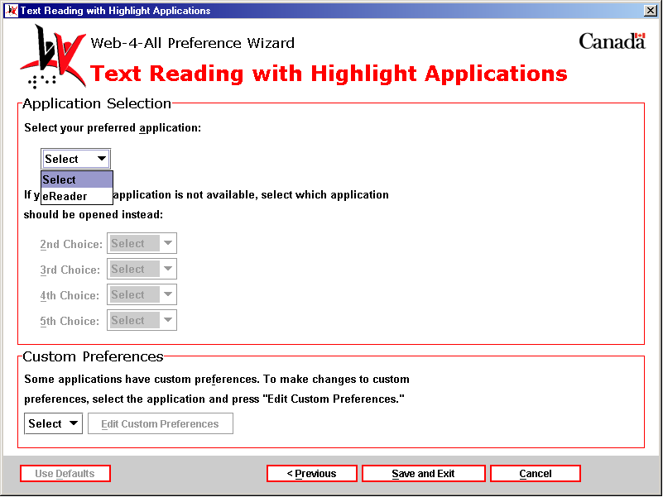

- Custom Preferences – This section enables users to configure the preference settings of any third party application listed on Web-4-All. Use the pull-down menu to choose an application and then select Edit Custom Preferences to access that particular application’s preference settings. These settings are stored on an individual’s Smart Card so that each time Web-4-All launches a favourite third party application those preferences will be automatically loaded along with the program.

3) “Read the screen to me.” – This option enables individuals with a visual impairment and those with cognitive disabilities to have the contents of each Web page read aloud. Selecting this checkbox launches the Screen Reader Settings dialog. Note: When this option is select some screen magnifiers and on-screen keyboards may not function.

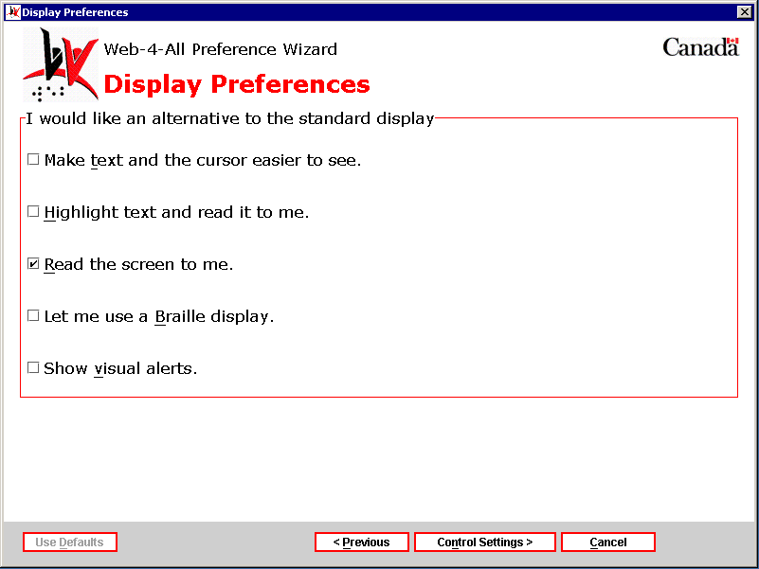

Screen Reader Settings dialog – The Screen Reader Settings dialog is divided into two sections: Link Preferences, and Voice Preferences. Each section is described in detail below.

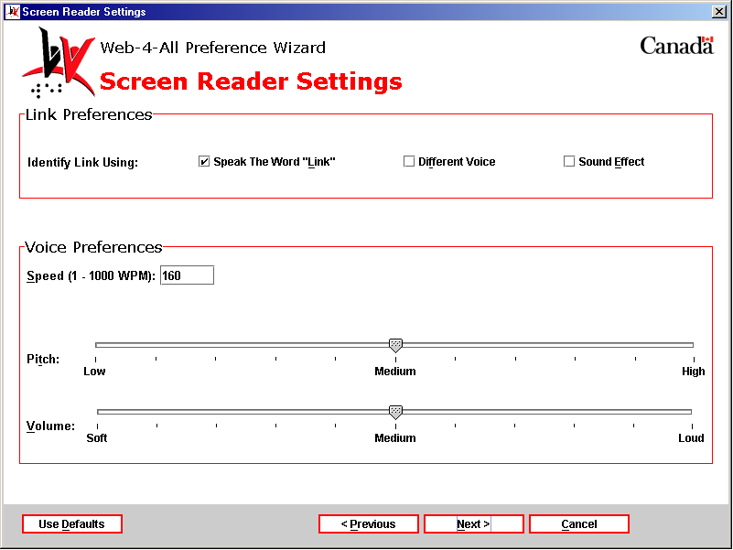

Link Preferences – This section features three checkbox selections: Speak The Word “Link”, Different Voice, and Sound Effect.

- Speak The Word “Link”: When this option is selected, the screen reader repeats the word “link” each time a hyperlink is encountered within a Web page.
- Different Voice: With this option selected, the voice used by Web-4-All’s screen reader changes each time a link is located in a Web document.
- Sound Effect: With this option selected, the screen reader emits a sound to alert the user that a hyperlink has been located.

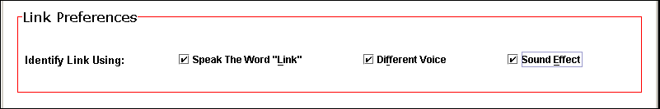

Voice Preferences – This section allows users to modify voice Speed, Pitch, and Volume levels.

- Speed: This option allows clients to control the speed at which the screen reader reads text. Users can enter a value ranging from 1 to 1000 words per minute (WPM) but the optimum range for most people is between 80 and 240 WPM. The default setting in Web-4-All is 160 WPM.
- Pitch: The screen reader’s voice Pitch is controlled by a sliding scale, which allows users to either lower (i.e. deepen) voice pitch or make it higher. The slider has three established settings: Low, Medium (the default), and High. There are four steps between Low and Medium and Medium and High. The slider’s pointer snaps to increments between marked values.
- Volume: The sliding scale for voice Volume allows clients with diminished or sensitive hearing levels to adjust the volume accordingly. Web-4-All offers three volume settings: Soft, Medium (the default), and Loud. As with Pitch, there are four steps between Low and Medium and Medium and High. The slider’s pointer snaps to increments between marked values.

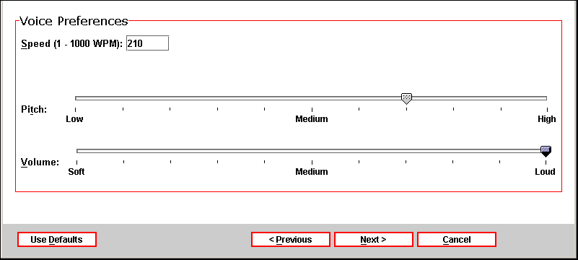

Once all selections have been made, select “Next” to advance to the Screen Reader Applications dialog.

Third Party Applications: The Screen Reader Applications dialog allows users to establish a third party program as their default screen enhancer. Each time a client’s Smart Card is inserted into a Web-4-All Card Reader, default applications selected by the user will also be launched. Because availability of third party applications varies from workstation to workstation, users can create a list of default screen enhancement applications and organize them in order of preference. For example, if a user’s initial selection is unavailable, Web-4-All will search for, and launch, their second choice, and so on. Up to five third party applications can be selected. Users also have the option of accessing third party preference settings via this dialog.

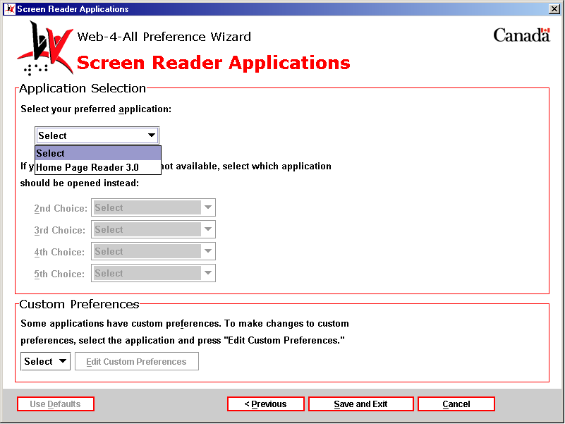

- Custom Preferences – This section enables users to configure the preference settings of any third party application listed on Web-4-All. Use the pull-down menu to choose an application and then select Edit Custom Preferences to access that particular application’s preference settings. These settings are stored on an individual’s Smart Card so that each time Web-4-All launches a favourite third party application those preferences will be automatically loaded along with the program.

4) “Let me use a Braille display.” – Refreshable Braille displays are devices connected to a computer producing Braille output one line of text at a time. These displays generally include directional keys allowing the user to navigate through a document. Selecting this checkbox launches the Braille Settings dialog.

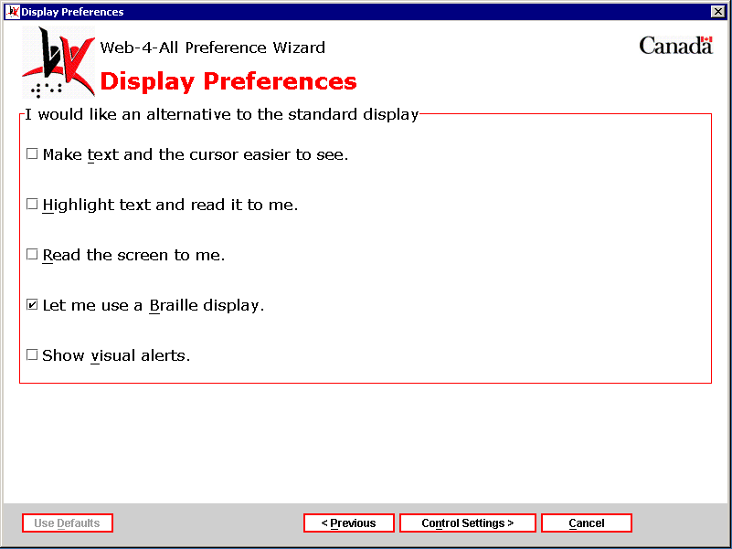

Braille Settings dialog – The Braille Settings dialog is divided into two sections: General Preferences and Mark Preferences.

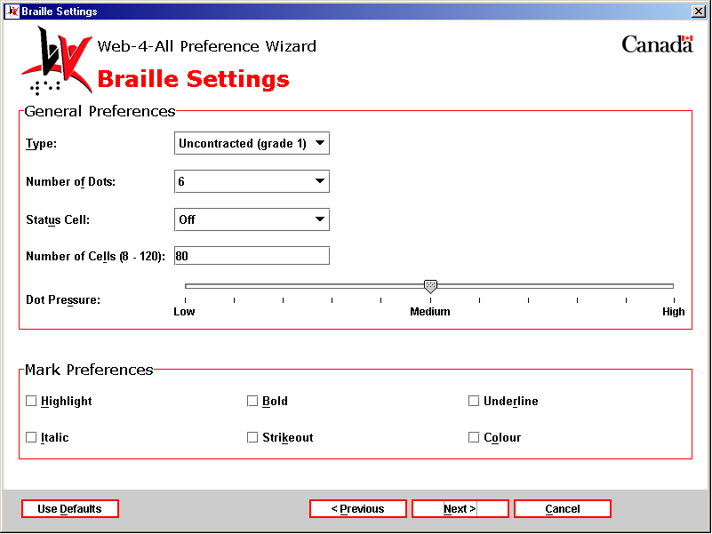

General Preferences – There are two types of Braille output available via computer – electronic Braille and embossed Braille. A device similar to a printer produces embossed Braille. To produce an electronic Braille display, a Braille display attaches to the Web-4-All workstation via a serial port. It translates text displayed on-screen into a representation of printed Braille. Electronic Braille displays range in size from one to eighty cells (a cell is equivalent to a printed character). Dedicated Braille displays are available in 20, 40, 65, or 80 cell versions but, instead of each cell possessing six dots as in printed Braille, electronic Braille usually includes eight cells. Typically, the seventh and eighth cells are used to display specific attributes such as capitalization or cursor location and so on. General Preferences features a pull-down menu with five different Braille settings: Type, Number of Dots, Status Cell, Number of Cells, and Dot Pressure.

- Type: This pull-down menu features two options: Uncontracted (grade 1) and Contracted (grade 2). Alphabetic Braille, also known as uncontracted or Grade 1 Braille refers to a Braille code made up of the letters of the alphabet, punctuation symbols and the number sign. It is capable of displaying virtually anything that can reasonably be considered text including: scientific expressions, symbols, math equations, as well as tabulated text and numbers. Contracted or Grade 2 Braille consists of the alphabet plus 189 one cell and two cell contractions representing various combinations of letters. Symbols are used to represent common letter combinations such as WO and ER and for words such as AND and FOR. A combination of two symbols is also used to represent some words such as THROUGH, for example. There are also dedicated codes for subjects like math and music. Although considered a more complex system, Grade 2 Braille is the standard form of literacy for individuals with a visual impairment primarily because of its space-saving properties and the increased reading speeds achieved by accomplished readers.

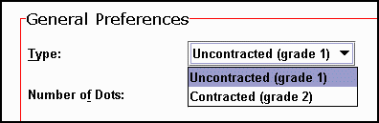

- Number of Dots: This pull-down menu enables users to select either 6 dots (the standard for printed Braille) or eight dots (customary for most electronic Braille displays – see General Preferences for more information).

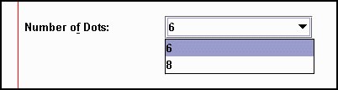

- Status Cell: The Status cell provides information about the vertical and horizontal positioning of the cursor and the Braille display focus on-screen. It can also be used to indicate text attributes at the cursor location, the number of items in a list or menu, and graphics displayed on-screen. Users can position the Status Cell on the left- or right-hand side of the Braille display, or turn this feature off altogether.

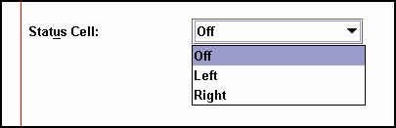

- Number of Cells (8-120): Braille displays have been designed to match the text display modes of computer screens. Full size Braille lines are typically 80 cells long (Web-4-All’s default), matching the number of characters in width for a typical word processing application. Braille lines with less than 80 cells display print lines in stages (i.e. a 20-cell line would display it in four stages).



- Dot Pressure: This sliding scale has three established settings: Low, Medium (the default), and High. It controls the pressure exerted on a users fingertips by the Braille display. There are four steps between Low and Medium and Medium and High. The slider’s pointer snaps to increments between marked values.

Mark Preferences – This section features six checkboxes that ensures Braille users are alerted when Highlight, Bold, Underline, Italic, Strikeout, and Colour are identified within a Web document.

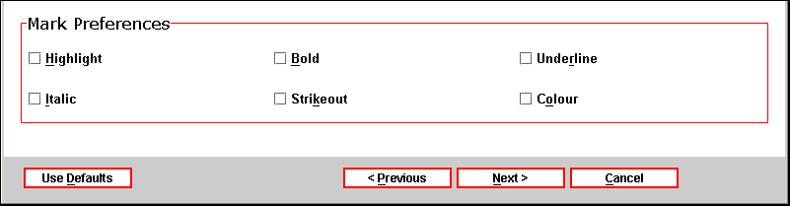

- Highlight: When this checkbox is checked, the user is alerted to instances of highlighted text within a Web page.
- Bold: All instances of bold text in a Web document trigger an alert when this checkbox is selected.
- Underline: The Braille display notifies the user of all underlined text when this checkbox is activated.
- Italic: The user is alerted whenever italic text is encountered within a Web page.
- Strikeout: When this checkbox is selected, the user is informed of all instances where strikeout has been used.
- Colour: The Braille display alerts the user when colour is used in a Web page.

Once all selections have been made, select “Next” to advance to the Braille Applications dialog.

Third Party Applications: The Braille Applications dialog allows users to establish a third party program as their default screen enhancer. Each time a client’s Smart Card is inserted into a Web-4-All Card Reader, default applications selected by the user will also be launched. Because availability of third party applications varies from workstation to workstation, users can create a list of default screen enhancement applications and organize them in order of preference. For example, if a user’s initial selection is unavailable, Web-4-All will search for, and launch, their second choice, and so on. Up to five third party applications can be selected. Users also have the option of accessing third party preference settings via this dialog.

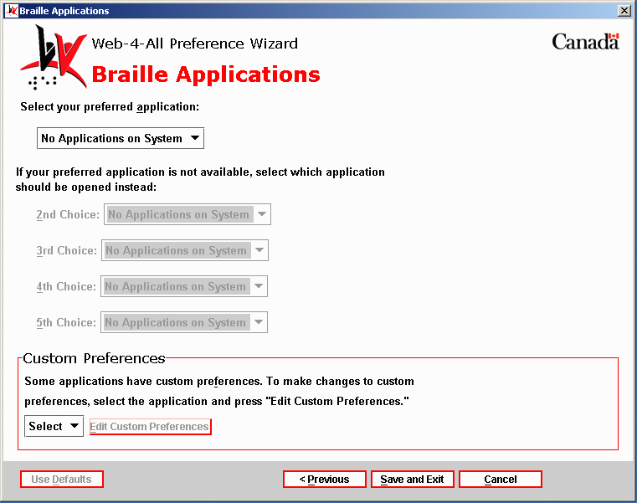

- Custom Preferences – This section enables users to configure the preference settings of any third party application listed on Web-4-All. Use the pull-down menu to choose an application and then select Edit Custom Preferences to access that particular application’s preference settings. These settings are stored on an individual’s Smart Card so that each time Web-4-All launches a favourite third party application those preferences will be automatically loaded along with the program.

5) “Show visual alerts.” – This checkbox provides hearing impaired users with various options for replacing computer sounds with visual signals or captioning.

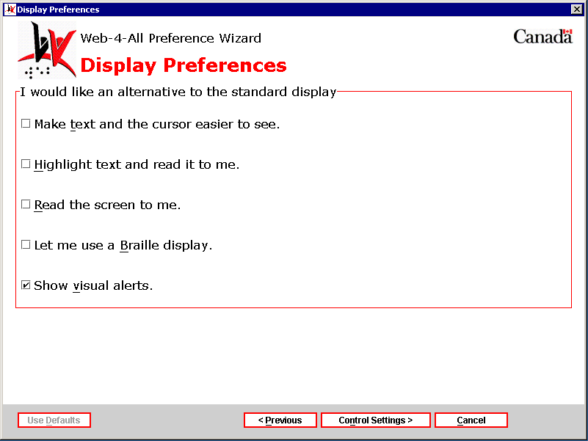

Visual Alert Settings dialog – This dialog presents users with a pull-down menu offering a variety of options to replace computer system sounds with visual alternatives. A checkbox also allows users to replace sounds with captioning.

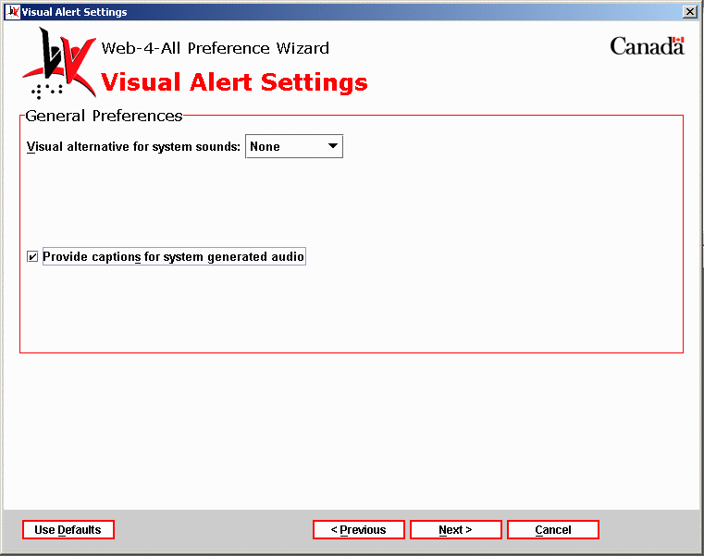

The Visual alternative for system sounds pull-down menu includes the following options:

- None – this option disables all visual alternatives to system sounds.
- Desktop – when this option is selected, the user’s desktop flashes in place of a system sound such as a beep.
- Caption Bar – the active caption bar flashes to alert users that a system sound has occurred.
- Window – the active window flashes alerting users that the computer has emitted a sound.

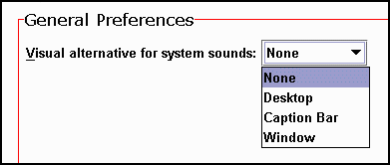

When the checkbox “Provide captions for system generated audio” is activated, all system-generated speech and sounds are converted into captions.



Once all selections have been made, select “Next” to advance to the Visual Alert Applications dialog.

Third Party Applications: The Visual Alert Applications dialog allows users to establish a third party program as their default screen enhancer. Each time a client’s Smart Card is inserted into a Web-4-All Card Reader, default applications selected by the user will also be launched. Because availability of third party applications varies from workstation to workstation, users can create a list of default screen enhancement applications and organize them in order of preference. For example, if a user’s initial selection is unavailable, Web-4-All will search for, and launch, their second choice, and so on. Up to five third party applications can be selected. Users also have the option of accessing third party preference settings via this dialog.

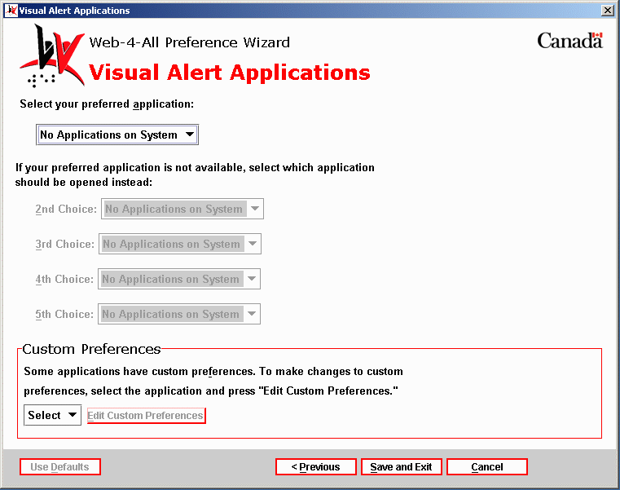

- Custom Preferences – This section enables users to configure the preference settings of any third party application listed on Web-4-All. Use the pull-down menu to choose an application and then select Edit Custom Preferences to access that particular application’s preference settings. These settings are stored on an individual’s Smart Card so that each time Web-4-All launches a favourite third party application those preferences will be automatically loaded along with the program.

Control Preference setting dialogs

I would like an alternative to the standard keyboard
This section allows clients to customize keyboard functionality. It is especially helpful to those who have difficulty using a standard keyboard because of mobility impairment.

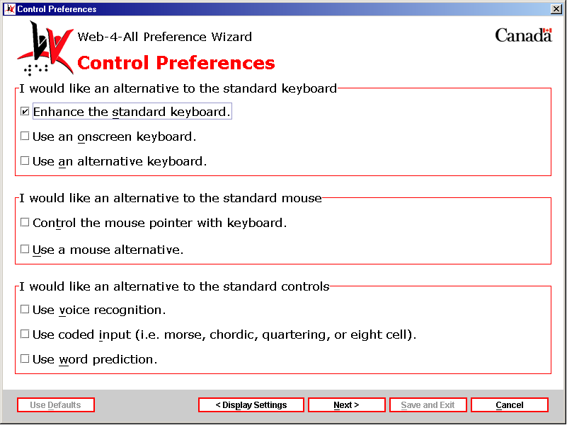

1) “Enhance standard keyboard.” – Those who find a standard keyboard difficult to use can reconfigure the layout to suit their own personal preferences and apply special features to keys. Select this checkbox and then “Next” to launch the “Keyboard Enhancement Settings” dialog.

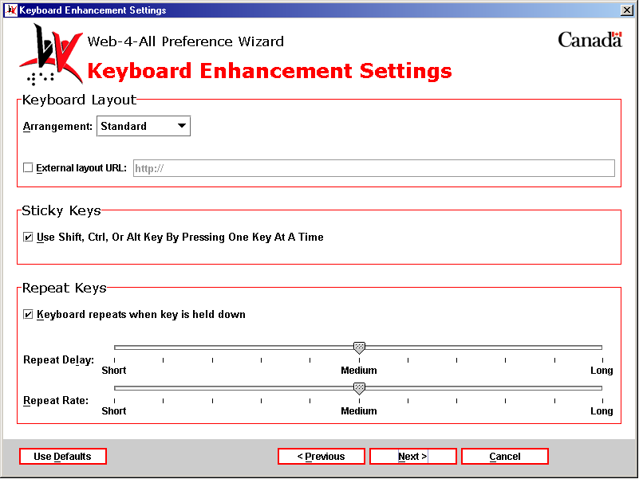

Keyboard Enhancement Settings: The Keyboard Enhancement Settings dialog includes the following three sections: Keyboard Layout, Sticky Keys, and Repeat Keys.

Keyboard Layout – This section allows users to select a specific keyboard layout for their specific needs via a pull-down menu. It also includes a checkbox that enables individuals to access an external keyboard online.

- Standard: This keyboard is Web-4-All’s default and is identical to the QWERTY U.S. English 101-key computer keyboard used with most systems.
- Sequential: The Sequential keyboard arranges letters alphabetically and numbers in ascending order.
- By Frequency: This keyboard is organized so that the most frequently used keys are located in the upper left-hand corner of the keyboard.

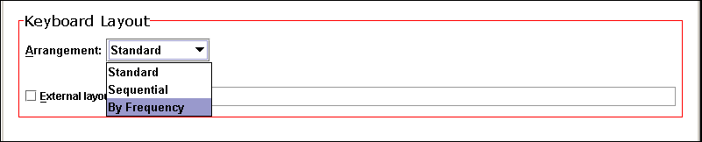

- External layout URL: This checkbox allows users to locate a specific keyboard configuration file via the Web and have those preferences loaded into Web-4-All.

Sticky Keys – This checkbox option assists clients with limited mobility in performing combination or multiple keystrokes (i.e. holding down the “Ctrl” and “Alt” keys and then depressing “Delete” to reset a computer). Selecting the checkbox, “Use Shift, Ctrl, or Alt Key By Pressing One Key At A Time” instructs the Web-4-All system to interpret a modifier key as being “held down” until a subsequent keystroke is completed.

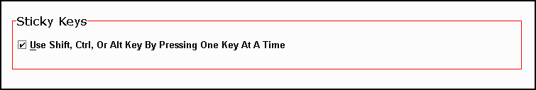

Repeat Keys – This option is designed for individuals who, because of a mobility problem such as a tremor, may inadvertently depress a key until the character is repeated multiple times on-screen. To access the Repeat Delay and Repeat Rate sliders, uncheck the “Keyboard repeats when key is held down” checkbox.

- Repeat Delay – The Repeat Delay slider enables clients to set a time delay between when a key is depressed and when it begins repeating the character. Values on the sliding scale range from Short to Medium (the default) to Long. The slider’s pointer snaps to increments between these values.
- Repeat Rate – The Repeat Rate slider determines the speed at which a character is repeated when a key is held down. Once again, the sliding scale’s values range from Short to Medium (the default) to Long. The slider’s pointer snaps to increments between these values.

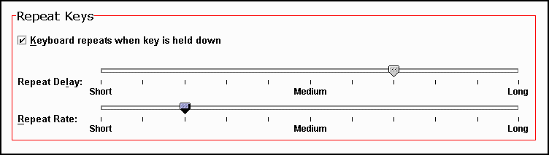

When the client is satisfied with their selections, choose “Next” to advance to page 2 of the Keyboard Enhancement Settings preferences.

Keyboard Enhancement Settings (page 2): The second Keyboard Enhancement Settings dialog allows users to enable and establish preference settings for Web-4-All’s Slow and Bounce Key features.

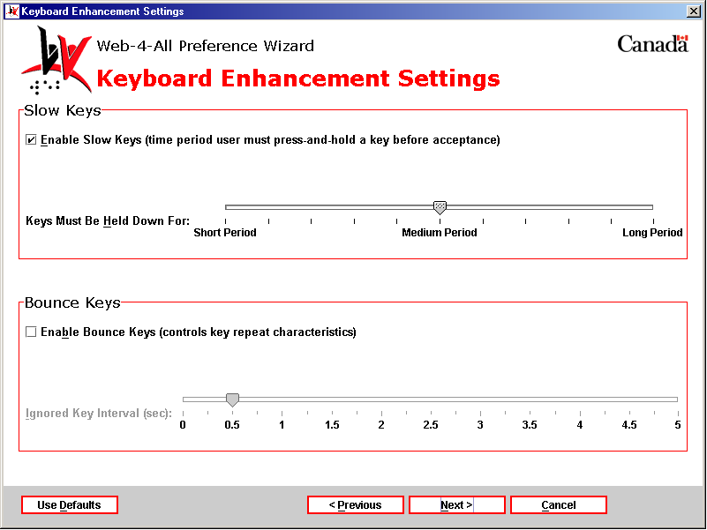

Slow Keys – The “Enable Slow Keys checkbox is checked by default. It allows the client to determine the duration a key must be depressed before it is interpreted as a legitimate keystroke. The sliding scale determines the length of time a key must be held down. It has three established settings: Short Period, Medium Period, and Long Period. Medium Period is the default. The slider’s pointer snaps to increments between these settings.

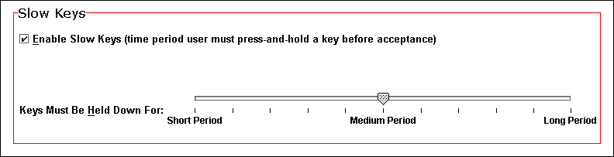

Bounce Keys – The “Enable Bounce Keys” checkbox is unchecked by default. If a client has the tendency to press a key and then accidentally press it again right away, use the Bounce Keys slider to create a delay after the initial keystroke. The key cannot be reactivated during this delay. The Bounce Keys option does not prevent users from typing as rapidly as possible, it simply prevents the same key from being pressed two consecutive times. The Ignored Key Interval slider sets the duration of the delay in seconds.

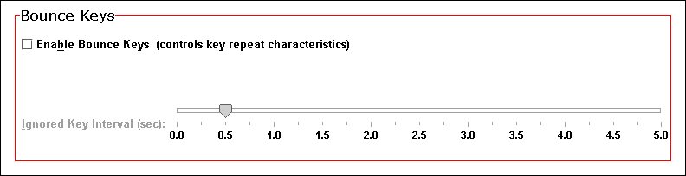

Once all selections have been made, select “Next” to advance to the Keyboard Enhancement Applications dialog.

Third Party Applications: The Keyboard Enhancement Applications dialog allows users to establish a third party program as their default screen enhancer. Each time a client’s Smart Card is inserted into a Web-4-All Card Reader, default applications selected by the user will also be launched. Because availability of third party applications varies from workstation to workstation, users can create a list of default screen enhancement applications and organize them in order of preference. For example, if a user’s initial selection is unavailable, Web-4-All will search for, and launch, their second choice, and so on. Up to five third party applications can be selected. Users also have the option of accessing third party preference settings via this dialog.

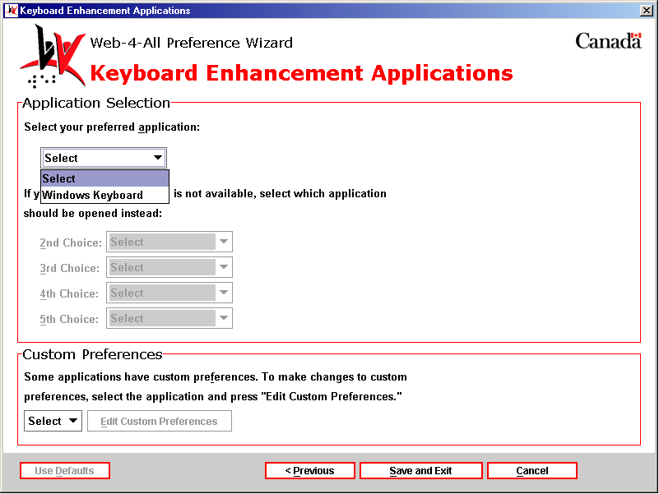

- Custom Preferences – This section enables users to configure the preference settings of any third party application listed on Web-4-All. Use the pull-down menu to choose an application and then select Edit Custom Preferences to access that particular application’s preference settings. These settings are stored on an individual’s Smart Card so that each time Web-4-All launches a favourite third party application those preferences will be automatically loaded along with the program.

2) “Use onscreen keyboard.” – This checkbox option enables clients to replace a standard computer keyboard with an onscreen keyboard. The onscreen keyboard can be operated using a standard mouse, HeadMouse, Trakker, HeadMaster, trackball, switch interface, or traditional joystick. It is especially useful to individuals with mobility impairments who find it difficult to use a standard keyboard. Note: When this checkbox is activated, certain screen magnifiers and screen readers may not function.

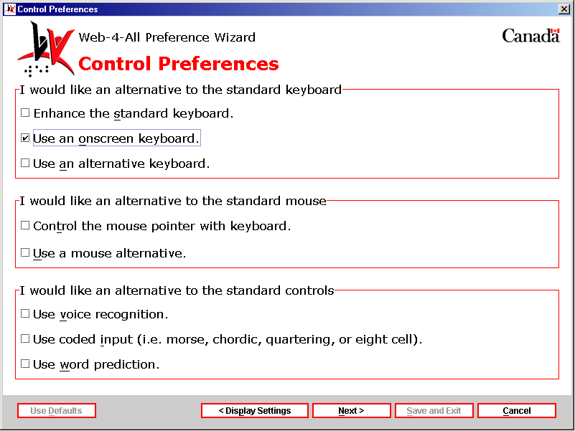

Select this checkbox and then “Next” to launch the “Onscreen Keyboard Settings” dialog.

Onscreen Keyboard Settings (page 1) – The first Onscreen Keyboard Settings dialog is divided into two sections: Key Preferences and Selection Method Preferences.

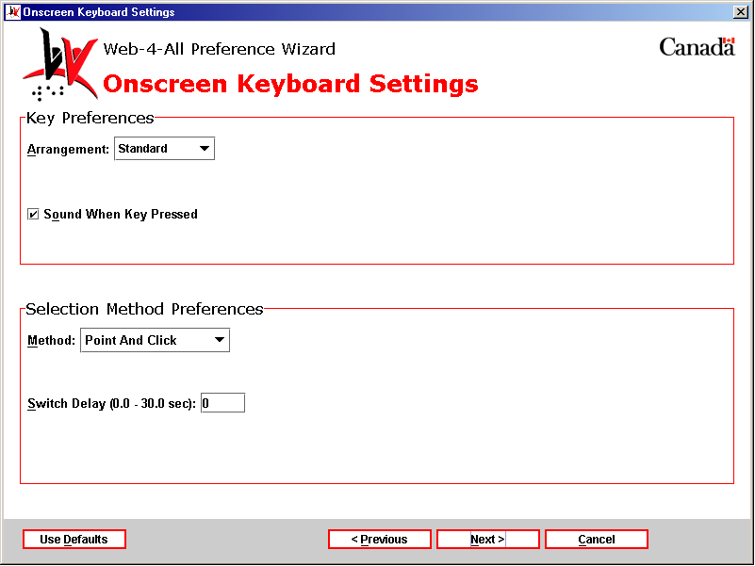

Key Preferences – Key Arrangement allows users to organize keys displayed onscreen in three different configurations. Key Sound is used to inform the client that a keystroke has been completed.

- Key Arrangement: The onscreen keyboard can be displayed in the following three formats: Standard, Sequential, and By Frequency. Selecting Standard launches the traditional Qwerty keyboard found on most computer systems. When Sequential is selected, the keys are presented in alphabetical/numerical order. When By Frequency is chosen, the most frequently used letters of the alphabet are grouped together for quick and easy access.

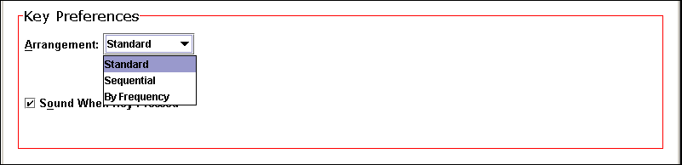

- Key Sound: If the client wishes to include sound with each completed keystroke, make sure the checkbox “Sound When Key Pressed” is checked. This is the default for this selection.

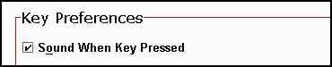

Selection Method Preferences – This section enables clients to choose how they will make selections from the onscreen display. They are offered six options: Point and Click (the default), Point and Dwell, Automatic Scanning, Inverse Scanning, Directed Scanning, and Code Selection. Each method will be addressed separately.

Method #1: Point and Click
Selecting Point And Click from the pull-down menu also displays a “Switch Delay” entry field. This method allows clients to select keys onscreen with a direct mouse click or switch input. The “Switch Delay” entry field controls the time delay between the mouse click and the onscreen key selection. It ranges from 0 (the default) to 30 seconds.

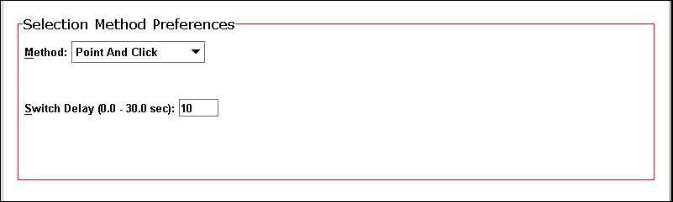

Once the Switch Delay time has been set, select the “Next” button to advance to page two of the Onscreen Keyboard Settings.

Onscreen Keyboard Settings (page 2) -- This dialog is divided into two sections: Key Sizes and a Preview Window. The first section allows users to set the width, height, and spacing of individual keys appearing in the onscreen keyboard. The Preview Window displays any adjustments to the sliding scales.

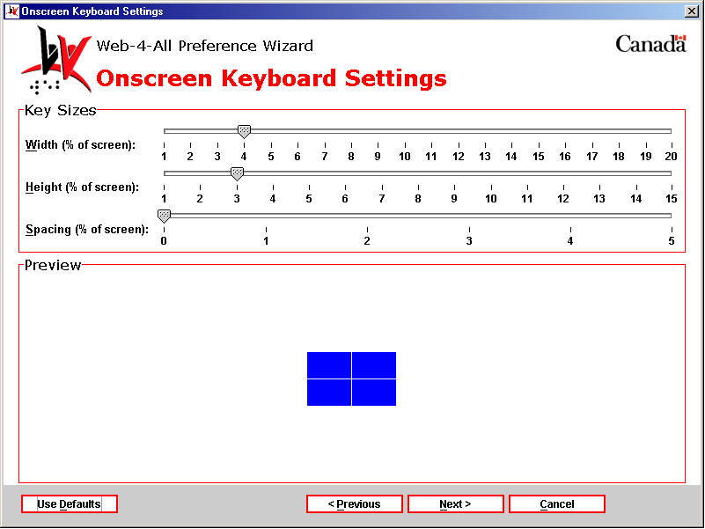

Key Sizes: This section includes three sliding scales. These settings enable the client to determine the overall dimensions of each key and the spacing between keys when displayed onscreen.

- Key Width – This option features a sliding scale that enables users to set key size as a percentage of the overall screen width. The scale ranges from one to 20 per cent (the default is four). Obviously, the larger the number the wider each individual key will appear onscreen. Changes made to Key Width are reflected in the Preview window.
- Key Height – This setting determines the height of each key via a sliding scale, which reflects a percentage of the overall height of the screen. The scale ranges from one to 15 per cent (the default is three). Once again, the larger the number the taller each individual key appears onscreen. These settings allow the client to determine the overall dimensions and the spacing between each key displayed on-screen.
- Key Spacing – This sliding scale determines the amount of space between each key. The scale represents a percentage of the overall screen width and ranges from zero to five per cent (the default is 0). In some instances, spacing can be increased to a point where only part of the onscreen keyboard will be visible at any given time and the user must move the scroll bars to view hidden portions.

The example below demonstrates the changes to the onscreen keys in the Preview Window by adjusting the three sliding scales.

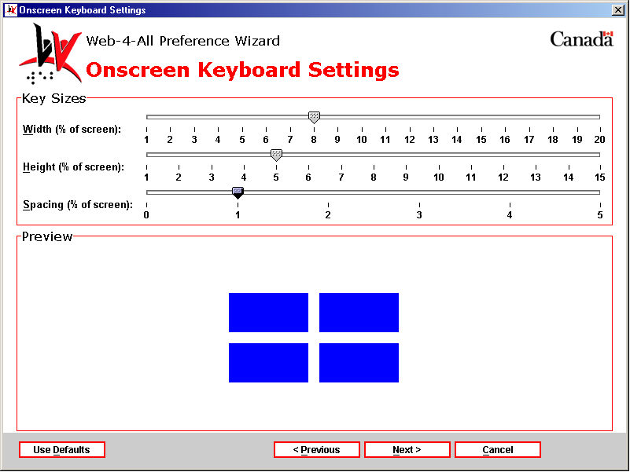

Once the user is satisfied with key width, height and spacing, select “Next” to advance to the Onscreen Keyboard Applications dialog.

Third Party Applications: The Onscreen Keyboard Applications dialog allows users to establish a third party program as their default screen enhancer. Each time a client’s Smart Card is inserted into a Web-4-All Card Reader, default applications selected by the user will also be launched. Because availability of third party applications varies from workstation to workstation, users can create a list of default screen enhancement applications and organize them in order of preference. For example, if a user’s initial selection is unavailable, Web-4-All will search for, and launch, their second choice, and so on. Up to five third party applications can be selected. Users also have the option of accessing third party preference settings via this dialog.

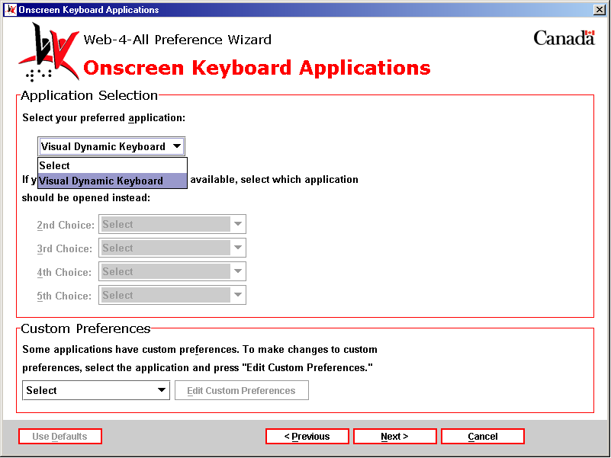

- Custom Preferences – This section enables users to configure the preference settings of any third party application listed on Web-4-All. Use the pull-down menu to choose an application and then select Edit Custom Preferences to access that particular application’s preference settings. These settings are stored on an individual’s Smart Card so that each time Web-4-All launches a favourite third party application those preferences will be automatically loaded along with the program.

Method #2: Point And Dwell
With Point And Dwell, selections are made by positioning the mouse pointer (or alternative pointing device) over a key for a specified length of time. Select Point And Dwell from the pull-down menu and then type in a value in the Dwell Time entry field. The Dwell Time scale ranges from 0 to a maximum of 3 seconds (0.5 is the default).

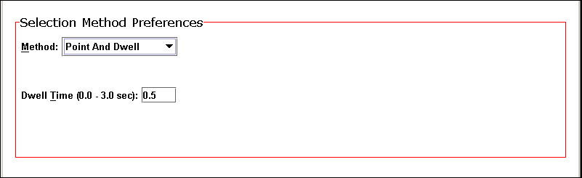

Once the Dwell Time has been set, select the “Next” button to advance to page two of the Onscreen Keyboard Settings.

Onscreen Keyboard Settings (page 2) -- This dialog is described in detail in the Point And Click section.

Once the user is satisfied with the settings for key width, height and spacing, select “Next” to advance to the Onscreen Keyboard Applications dialog which is described in Point And Click.

Method #3: Automatic Scanning
When this option is selected, individual rows and columns are automatically highlighted and clients select a specific key using either a switch or left mouse button. There are four additional options associated with this selection. They are: Scan Speed, Repeat Cycles, Switch Delay, and Initial Delay.

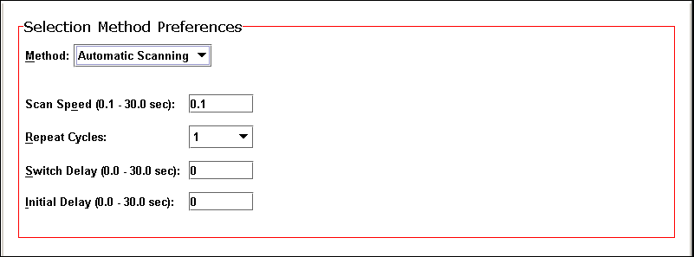

- Scan Speed – This entry field accepts values ranging from 0.1 to 30 seconds (0.1 second is the default) and determines the speed at which the rows and columns are scanned.

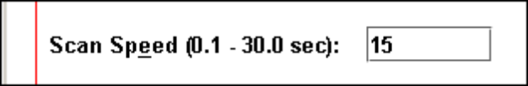

- Repeat Cycles – This pull-down menu enables clients to have the onscreen keyboard automatically repeat its scan cycle if a selection has not been made. The scan cycle can be repeated up to 5 times or it can be set to repeat indefinitely until a selection is made.

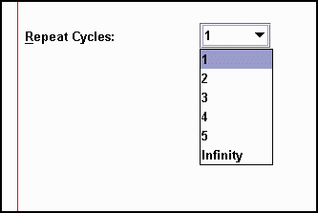

- Switch Delay – This entry field controls how quickly the onscreen keyboard responds to user input (i.e. a mouse click, etc.) Switch Delay ranges from 0 (the default) to 30 seconds.



- Initial Delay – This entry field also ranges from 0 to 30 seconds. It determines the length of time the highlight pauses before moving on to the next row, column or key when performing a scan.



Once these settings have been adjusted, select the “Next” button to advance to page two of the Onscreen Keyboard Settings. (Note: Page two for Automatic Scanning, Inverse Scanning, and Directed Scanning differs from the one that appears when the Point And Click, Point And Dwell, or Code Selection is chosen as the Selection Method.)

Onscreen Keyboard Settings (page 2) -- This dialog is divided into two sections: Switch Input Preferences and Switch Assignment Preferences. The first section allows users to choose the type of input device and number of switches to be used in making onscreen keyboard selections. It also allows users to choose dwell as an option and set a specific dwell time when this feature is applicable.

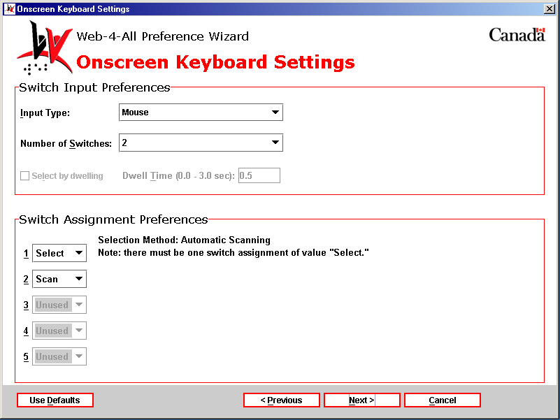

Switch Input Preferences – This section features the following two pull-down menus: Input Type and Number of Switches.

- Input Type: This option allows users to choose the type of input device and port used to control the onscreen keyboard. Individuals who have a mobility impairment that makes it difficult to use a standard keyboard often rely on switches to control with a computer. A switch may be a single button, several buttons, or a sensory plate. It can also be touch-free, activated instead through a sip and puff mechanism or via motion sensors triggered by a head wand, eye movement, or even blinking. The default Input Type for Automatic Scanning is Mouse.

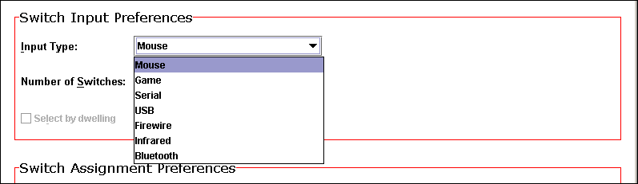

- Mouse – Selecting this option from the pull-down menu allows the client to use the mouse pointer and/or buttons as their input switch. The Mouse is often used as a switch for those using the Point And Click or Point And Dwell selection methods.

- Game – This option allows users to replace the mouse with an alternative-pointing device such as a joystick or trackball. If the user selects joystick, they can have up to five switches controlling the onscreen keyboard.

- Serial – Serial ports provide a standard connector and protocol to attach a variety of devices to a computer. Considered one of the most basic external connections, virtually all computer systems support serial ports. Serial devices are bi-directional; that is, they allow each device to both receive and transmit data.

- USB – USB or Universal Serial Bus connectors allow users to attach up to 127 devices to a computer quickly and easily. Each device can use up to a maximum bandwidth of 6 megabits per second, which is fast enough for most peripheral devices that can be connected to a computer. Operating systems also support USB, making the installation of device drivers fast and easy, as well.

- Firewire – While USB is the preferred technology for most computer mouse, keyboard, or other lower bandwidth input device, Firewire is the interface of choice for high-speed peripherals. With its higher bandwidth, longer distances and much higher-powered bus, Firewire is the standard for digital audio and video devices, as well as external hard drives and other high-speed data transfer applications.

- Infrared – Infrared switches operate in similar fashion to remote devices controlling DVD players, VCRs, televisions, and so on. They are basically line-of-sight devices that act as a switch by emitting a low-powered infrared beam, which closes a relay. Note, a computer must be equipped with an infrared sensor for this option to function.

- Bluetooth™ – This wireless technology functions similarly to infrared but offers much greater range than line-of-sight functionality. Bluetooth™ enables linking between mobile computers, mobile phones, and portable handheld devices. Relying on a radio system, Bluetooth™ technology is supported by a wide range of products and applications and offers global compatibility.

- Number of Switches: Users can select up to five input switches for controlling the onscreen keyboard. As an example, a mouse button or foot pedal might be used as a single switch device whereas a multi-directional joystick is capable of functioning as a five-switch input device. When Automatic Scanning is selected as the user’s Selection Method, the default Number of Switches is set at two.

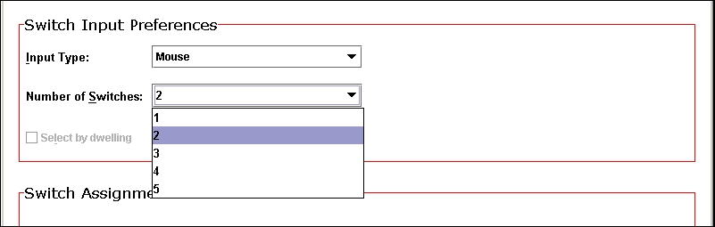

- Dwell Time: As previously described, Dwell Time determines the length of time a mouse or other pointing device must remain over a key for it to trigger an action. This checkbox and entry field is inactive (greyed out) when Automatic Scanning has been chosen as the Selection Method.

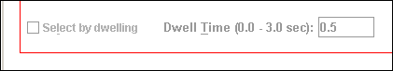

Switch Assignment Preferences – This section allows users to assign a specific behaviour to each individual switch. Switches can be assigned three active states or functions. They are: Select (selects or activates a key), Cancel (cancels or stops an action), and Scan (highlights a specific key). Up to 5 separate switches can be assigned their own unique behaviour.

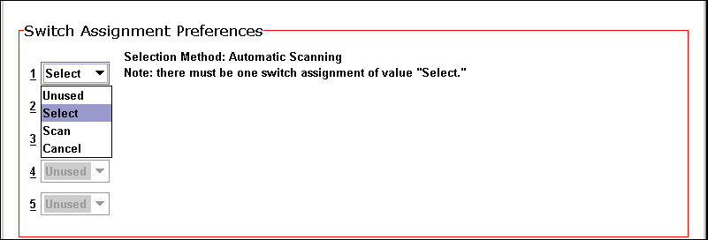

When Automatic Scanning has been chosen as the Selection Method, the defaults are Select for switch number one and Scan for switch number two. As noted in the dialog above, Automatic Scanning requires at least one switch to be assigned the value “Select.”

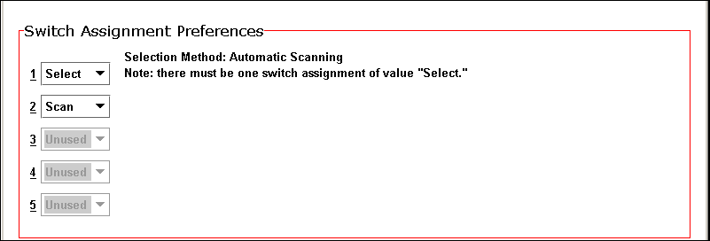

Once selections have been made for the Switch Input and Switch Assignment Preferences, use “Next” to advance to the third Onscreen Keyboard Settings dialog. This dialog, which allows users to set the width, height, and spacing of individual keys within the onscreen keyboard, is identical to the Onscreen Keyboard Settings (page 2) dialog launched when users select Point And Click, Point And Dwell or Code Selection as their selection method.

Onscreen Keyboard Settings (page 3) – This dialog is described in detail in the Point And Click section.

Once the user is satisfied with the settings for key width, height and spacing, select “Next” to advance to the Onscreen Keyboard Applications dialog described in Point And Click.

Method #4: Inverse Scanning
Inverse Scanning is similar to automatic scanning, because it uses row-column scanning to specify a key selection. The main difference is that scanning (moving the highlight down rows or across columns) proceeds only when the user keeps switch 1 depressed. To stop the highlight movement when the desired row or column is reached, the switch is released. To make a selection, press and release switch 2. To continue scanning without having made a selection, press and hold switch 1 again.

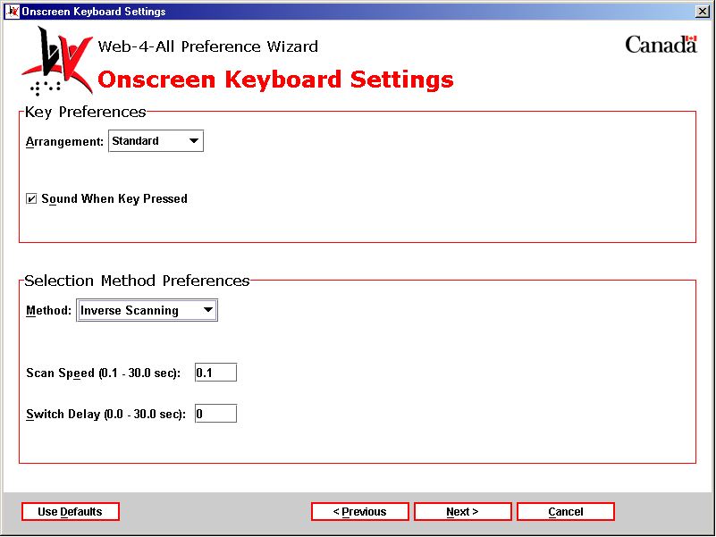

Onscreen Keyboard Settings (page 1) – Key Preferences are described in the Point And Click section. Both Scan Speed and Switch Delay are described in Automatic Scanning.

Once settings have been established for Key and Selection Method Preferences, use “Next” to advance to the Onscreen Keyboard Settings (page 2) – Switch Input and Switch Assignment Preferences.

Onscreen Keyboard Settings (page 2) – The Switch Input and Switch Assignment Preferences are described in detail in Automatic Scanning. Note, however, that the default for Input Type is Mouse and the Number of Switches is two when Inverse Scanning is the chosen Selection Method. In addition the “Select by dwelling” checkbox becomes active.

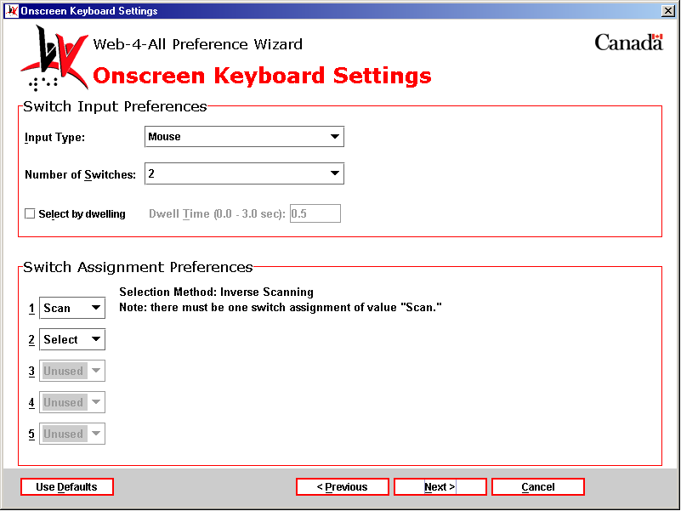

Select by dwelling – This checkbox becomes active when a selection method includes dwell as an option. Once the checkbox has been selected, the entry field allows a user to type in a value ranging from 0 to 3 seconds (.5 seconds is the default).

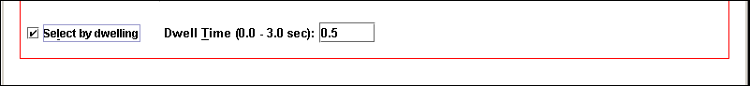

Switch Assignment Preferences – This section is described in detail in Automatic Scanning. Note, however, that when Inverse Scanning is the chosen Selection Method the default for the first switch is Scan while the default for the second switch is Select. As indicated in the dialog, when Inverse Scanning is used, one switch must be assigned the value of Scan.

Once selections have been made for the Switch Input and Switch Assignment Preferences, use “Next” to advance to the third Onscreen Keyboard Settings dialog. This dialog, which allows users to set the width, height, and spacing of individual keys within the onscreen keyboard, is identical to the Onscreen Keyboard Settings (page 2) dialog launched when users select Point And Click, Point And Dwell or Code Selection as their selection method.

Onscreen Keyboard Settings (page 3) – This dialog is described in detail in the Point And Click section.

Once the user is satisfied with the settings for key width, height and spacing, select “Next” to advance to the Onscreen Keyboard Applications dialog described in Point And Click.

Method #5: Directed Scanning
Directed Scanning enables clients to control the movement of the highlight by using separate switches. Items are selected by activating a switch set to Select or by Dwelling. Joysticks, similar to those used to control an electric wheelchair, are often used with Directed Scanning.

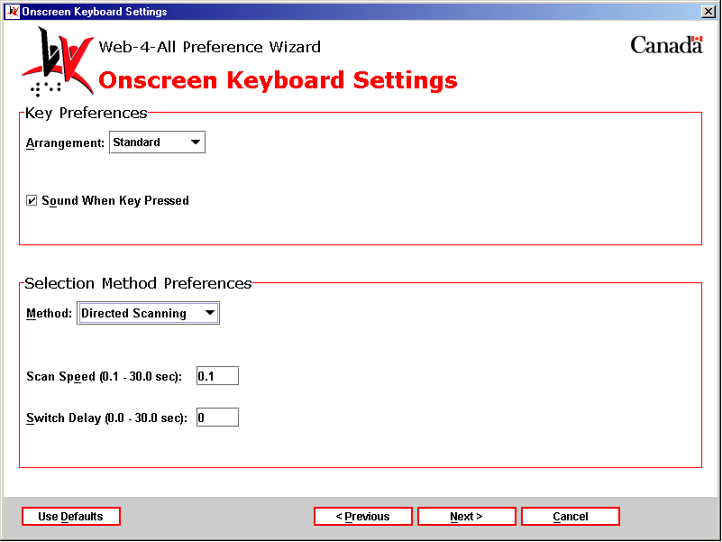

Onscreen Keyboard Settings (page 1) – Key Preferences are described in the Point And Click section. Both Scan Speed and Switch Delay are described in Automatic Scanning.

Once settings have been established for Key and Selection Method Preferences, use “Next” to advance to the Onscreen Keyboard Settings (page 2) – Switch Input and Switch Assignment Preferences.

Onscreen Keyboard Settings (page 2) – The Switch Input and Switch Assignment Preferences are described in detail in Automatic Scanning. Note, however, that the default for Input Type is Mouse but the Number of Switches is five when Directed Scanning is the chosen Selection Method. In addition the “Select by dwelling” checkbox becomes active.

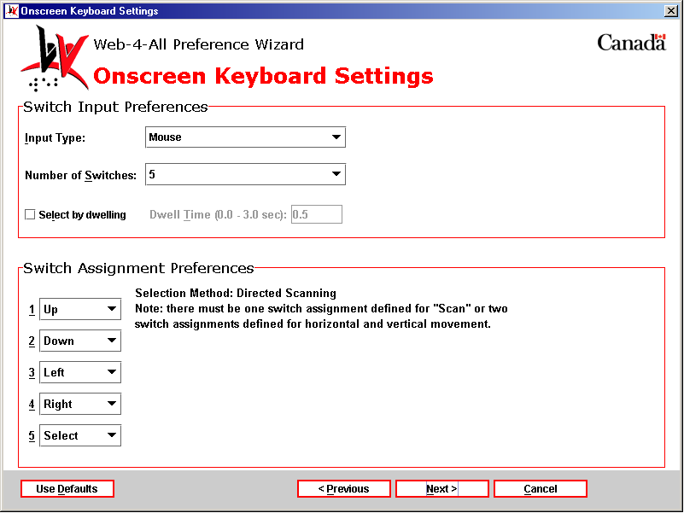

Select by dwelling – This checkbox is described in detail in Inverse Scanning.

Switch Assignment Preferences – This section is described in detail in Automatic Scanning. Note, however, that when Directed Scanning is the chosen Selection Method the defaults for the first four switches are Up, Down, Left and Right while the default for the fifth switch is Select. This type of switch configuration is consistent with a joystick input device. As indicated in the dialog, when Directed Scanning is used, at least one switch must be assigned the value of Scan and two other switches must be dedicated to horizontal and vertical movement.

Once selections have been made for the Switch Input and Switch Assignment Preferences, use “Next” to advance to the third Onscreen Keyboard Settings dialog. This dialog, which allows users to set the width, height, and spacing of individual keys within the onscreen keyboard, is identical to the Onscreen Keyboard Settings (page 2) dialog launched when users select Point And Click, Point And Dwell or Code Selection as their selection method.

Onscreen Keyboard Settings (page 3) – This dialog is described in detail in the Point And Click section.

Once the user is satisfied with the settings for key width, height and spacing, select “Next” to advance to the Onscreen Keyboard Applications dialog which is described in Point And Click.

Method #6: Code Selection
When Code Selection is the selection method no associated options are readily apparent but when this option is selected the Use coded input checkbox (option seven) on the Control Preferences dialog is automatically checked. “Next” advances clients to the Onscreen Keyboard Settings dialog used to set key width, height and spacing which is described in detail in the Point And Click section.

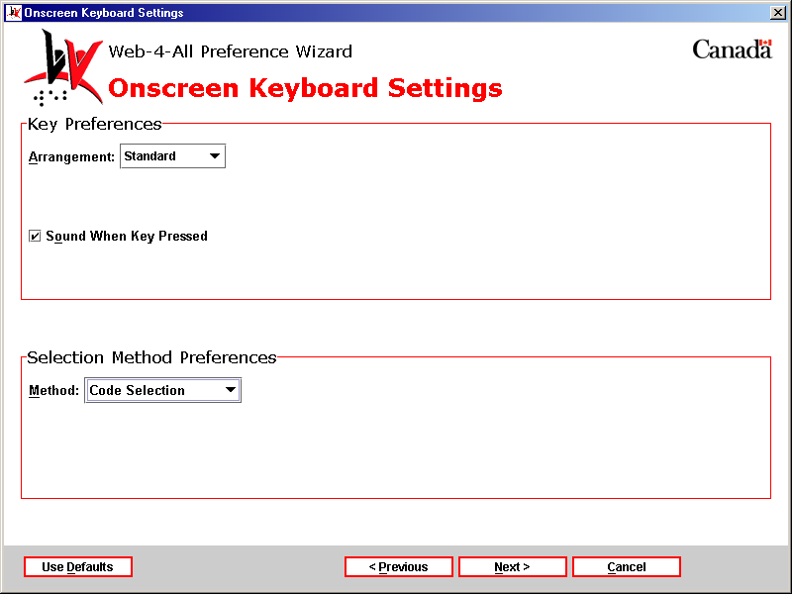

Once the user is satisfied with the settings for key width, height and spacing, select “Next” to advance to the Onscreen Keyboard Applications dialog described in detail in Point And Click.

Note: If no other checkboxes have been selected from Control Preferences, then the Code Input Settings dialog (described in checkbox option number eight) will be launched next. If additional checkboxes preceding option number eight are checked in the Control Preferences dialog, then Web-4-All will launch those setup dialogs in sequential order before advancing to Code Input Settings.

3) “Use alternative keyboard.” – This option allows users to create a more accessible alternative to the standard Qwerty keyboard. Users are able to alter their keyboard configuration, add Sticky and Repeat keys, and enable Slow and Bounce key options. The Alternative Keyboard Settings also enables users to change the dimensions of individual keys in an onscreen keyboard. Select this checkbox and then “Next” to launch the Alternative Keyboard Settings dialog.

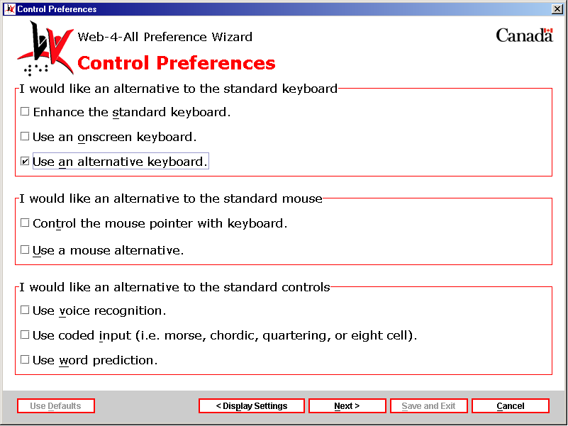

The first Alternative Keyboard Settings dialog is divided into three separate sections. They are: Keyboard Layout, Sticky Keys, and Repeat Keys. The options listed in this dialog are identical to those found in Keyboard Enhancement Settings (checkbox number one on the Control Preferences dialog). For a detailed explanation of each option see Enhance the standard keyboard.

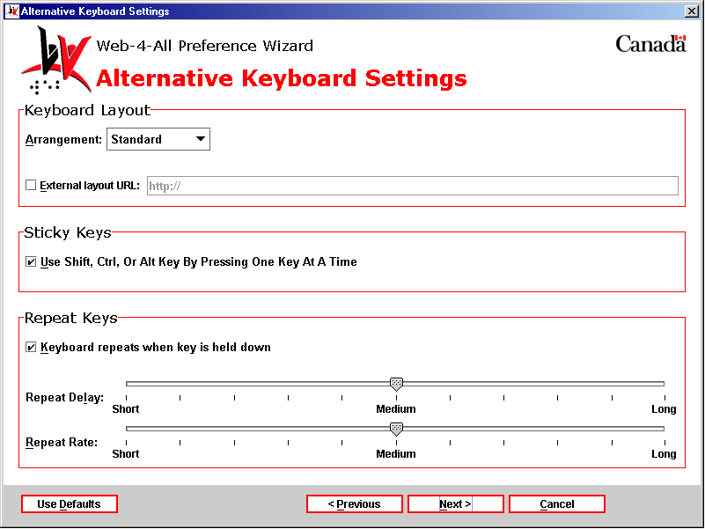

Once settings for Keyboard Layout, Sticky Keys and Repeat Keys have been established, select “Next” to advance to page 2 of the Alternative Keyboard Settings preferences.

Alternative Keyboard Settings (page 2): This dialog allows users to enable and establish preference settings for Web-4-All’s Slow and Bounce Key features. The options appearing in this dialog are identical to those found on page two in the Keyboard Enhancement Settings section. For a detailed explanation of each option see the Enhance the standard keyboard section.

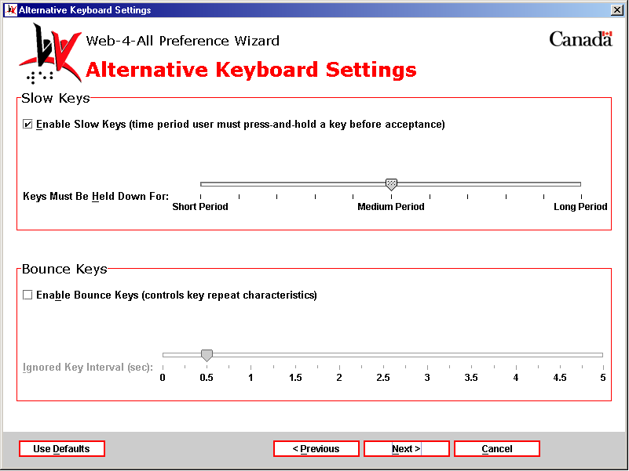

After settings for Slow and Bounce Keys have been made, select “Next” to advance to page three of the Alternative Keyboard Settings.

Alternative Keyboard Settings (page 3): This dialog includes only one section: Key Sizing Preferences. It enables clients to increase the width, height, and/or spacing of individual keys in an onscreen keyboard by as much as 100mm.

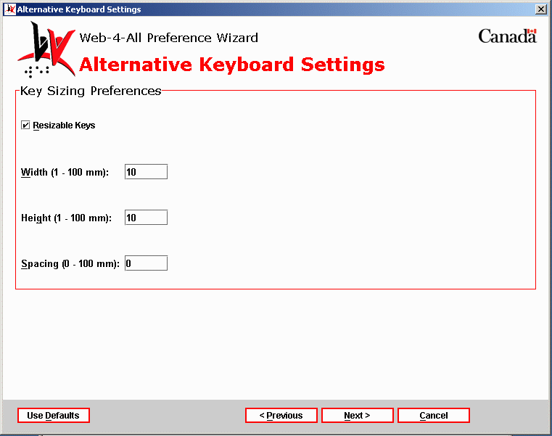

Key Resizing Preferences – To enable the Width, Height, and Spacing entry fields select the Resizable Keys checkbox. Each entry field accepts values ranging from 1 to 100mm. The default value for the three fields is 10mm. Unlike the Onscreen Keyboard Settings, this dialog does not include a Preview window.

Once all selections have been made, select “Next” to advance to the Alternative Keyboard Applications dialog.

Third Party Applications: The Alternative Keyboard Applications dialog allows users to establish a third party program as their default screen enhancer. Each time a client’s Smart Card is inserted into a Web-4-All Card Reader, default applications selected by the user will also be launched. Because availability of third party applications varies from workstation to workstation, users can create a list of default screen enhancement applications and organize them in order of preference. For example, if a user’s initial selection is unavailable, Web-4-All will search for, and launch, their second choice, and so on. Up to five third party applications can be selected. Users also have the option of accessing third party preference settings via this dialog.

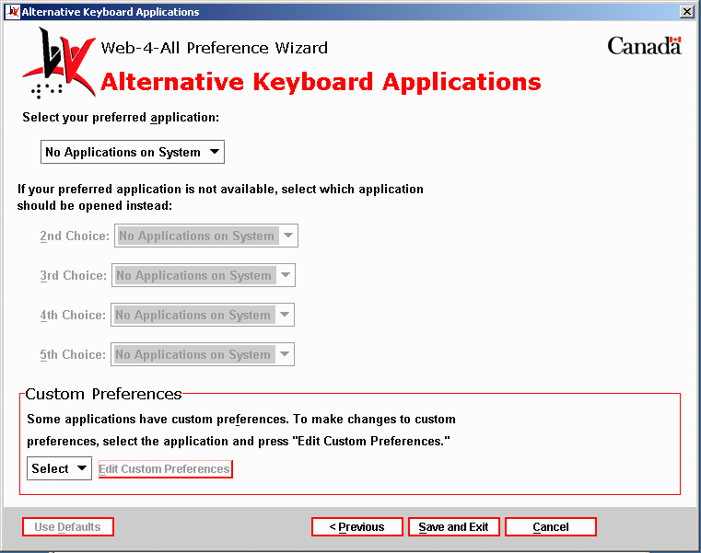

- Custom Preferences – This section enables users to configure the preference settings of any third party application listed on Web-4-All. Use the pull-down menu to choose an application and then select Edit Custom Preferences to access that particular application’s preference settings. These settings are stored on an individual’s Smart Card so that each time Web-4-All launches a favourite third party application those preferences will be automatically loaded along with the program.

I would like an alternative to the standard mouse
This option allows clients to replace the standard computer mouse with an alternate pointing device. This option is especially helpful to those who have difficulty performing fine motor control movements.

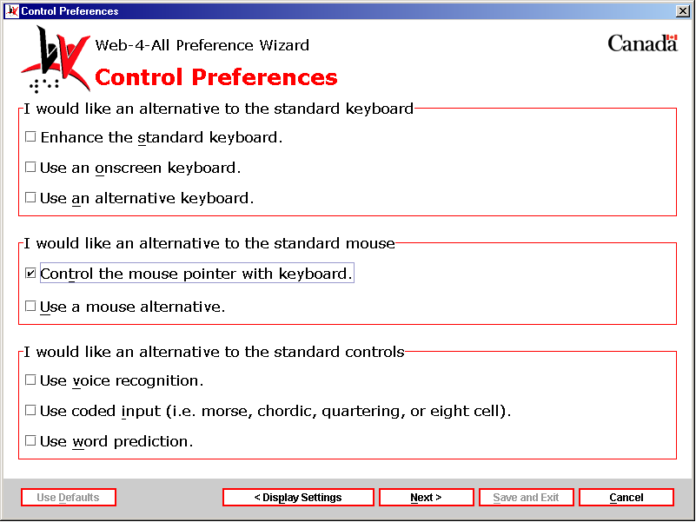

4) “Control the mouse point with keyboard.” – Those who find a standard mouse difficult to use can control the mouse pointer with the keyboard. Select this checkbox and then “Next” to launch the “Mouse Emulation Settings” dialog.

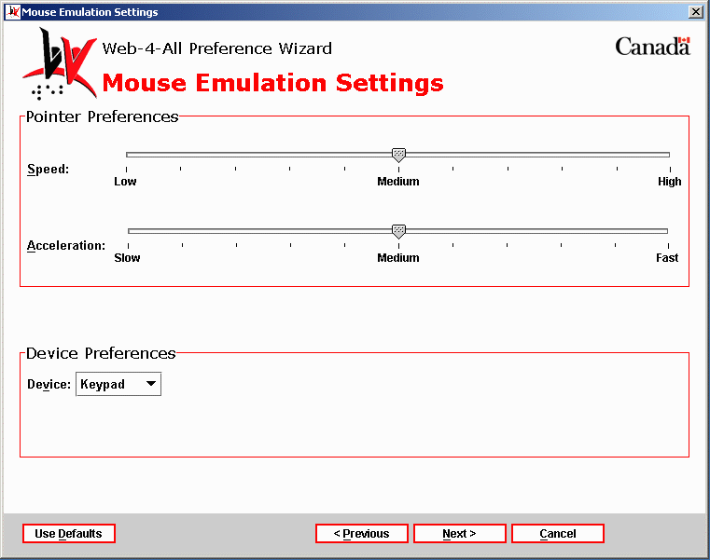

Mouse Emulation Settings – This dialog is divided into two sections: Pointer Preferences and Device Preferences.

Pointer Preferences – This section features two sliding scales controlling pointer Speed and Acceleration.

- Pointer Speed: This sliding scale controls how quickly the mouse pointer reacts to keyboard input. The scale has three marked settings: Low, Medium (default), and High.
- Pointer Acceleration: This setting allows clients to control how rapidly the mouse pointer accelerates across the screen (when scrolling, for example.) This scale includes the following settings: Slow, Medium (default), and Fast.

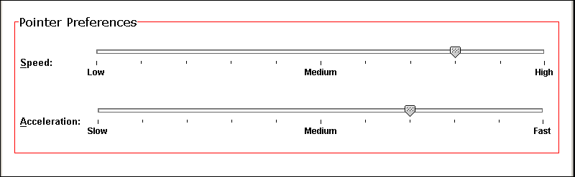

Device Preferences – This section features a pull-down menu, which allows users to specify a particular device to control the mouse pointer. Options include: Keypad, Keyboard, and Switch.

- Keypad: This refers to a numeric keypad containing the numbers 0 through 9 and a decimal point arranged as on an adding machine. Numeric keypads are often incorporated into standard computer keyboards, but they can also be independent devices that must be connected to the computer. Frequently, the keys on the numeric keyboard also serve as cursor control keys (i.e. arrow keys).
- Keyboard: This setting allows clients to control the mouse pointer using a standard keyboard’s arrow keys.
- Switch: When Switch is selected, a device with switch activation (e.g. a joystick, trackball, etc.) controls the mouse pointer. The more switches available to the user, the faster the pointer can be moved across the screen.

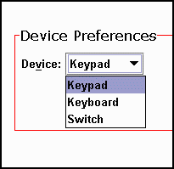

Once all selections have been made, select “Next” to advance to the Mouse Emulation Applications dialog.

Third Party Applications: The Mouse Emulation Applications dialog allows users to establish a third party program as their default screen enhancer. Each time a client’s Smart Card is inserted into a Web-4-All Card Reader, default applications selected by the user will also be launched. Because availability of third party applications varies from workstation to workstation, users can create a list of default screen enhancement applications and organize them in order of preference. For example, if a user’s initial selection is unavailable, Web-4-All will search for, and launch, their second choice, and so on. Up to five third party applications can be selected. Users also have the option of accessing third party preference settings via this dialog.

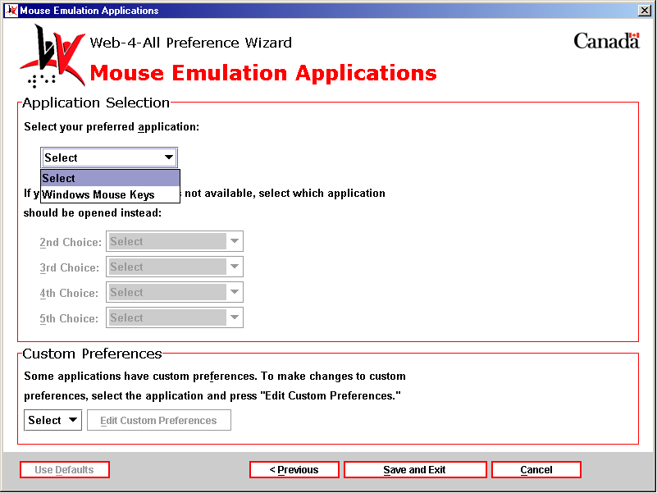

- Custom Preferences – This section enables users to configure the preference settings of any third party application listed on Web-4-All. Use the pull-down menu to choose an application and then select Edit Custom Preferences to access that particular application’s preference settings. These settings are stored on an individual’s Smart Card so that each time Web-4-All launches a favourite third party application those preferences will be automatically loaded along with the program.

5) “Use a mouse alternative.” – This option allows users to modify the controls of a standard mouse pointer to meet their particular needs. Select this checkbox and then “Next” to launch the “Alternative Pointing Settings” dialog.

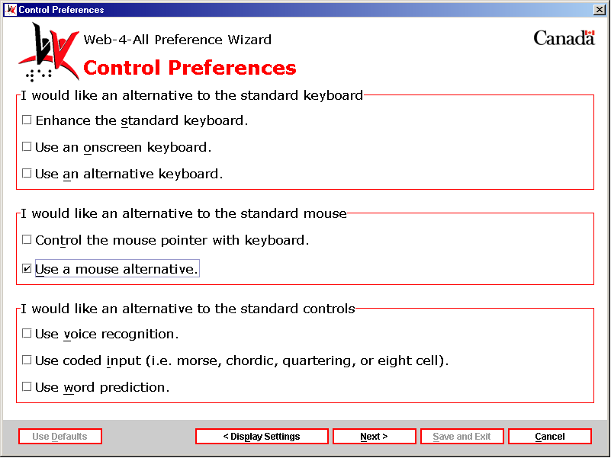

Alternative Pointing Settings – This dialog is divided into four sections: Mouse Orientation, Double-click Delay, Pointer Preferences and Alternative Button Assignment.

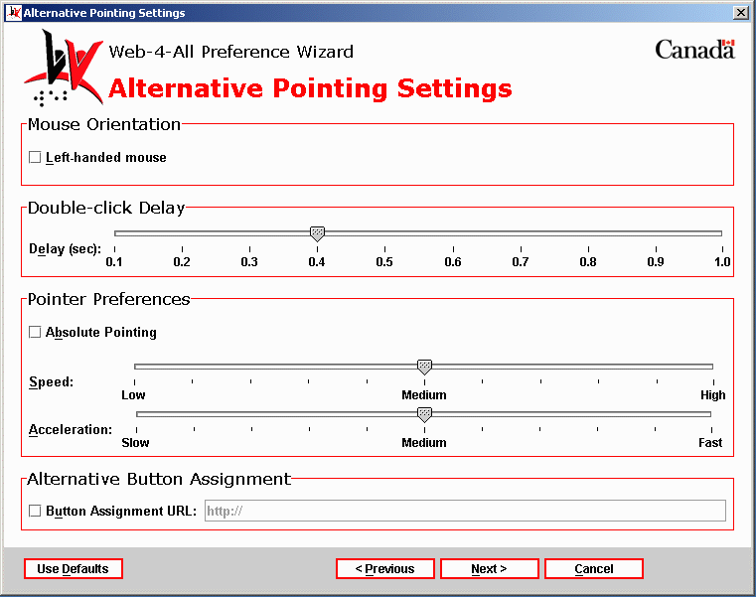

Mouse Orientation – By default, the position of the mouse is geared towards right-handed users. This checkbox, however, allows users to change the mouse orientation to suit left-handed individuals.
Double-click Delay – This option, controlled by a slider ranging from 0.1 seconds to 1 second, enables uses to insert a time delay between a double-click (i.e. the user presses and releases the left mouse button twice in rapid succession.)
Pointer Preferences – This section offers users three settings options: Absolute Pointing, Speed, and Acceleration.
- Absolute Pointing: Individuals with mobility impairments sometimes use absolute location pointing devices such as graphics displays in place of a mouse to map to a specific location on-screen. When this checkbox is selected it disables the Speed and Acceleration sliders described below.
- Speed: This sliding scale controls how quickly the pointer reacts to keyboard input. The scale has three marked settings: Low, Medium (default), and High. The slider pointer snaps to increments between each setting.
- Acceleration: This setting allows clients to control how rapidly the pointer accelerates across the screen (when scrolling, for example.) This scale includes the following settings: Slow, Medium (default), and Fast. Once again, the slider pointer snaps to increments between each setting.

Alternative Button Assignment – This checkbox allows users to access a file from an external source. This file would reconfigure the current button assignments used on the system.

Once all selections have been made, select “Next” to advance to the Alternative Pointing Applications dialog.

Third Party Applications: The Alternative Pointing Applications dialog allows users to establish a third party program as their default screen enhancer. Each time a client’s Smart Card is inserted into a Web-4-All Card Reader, default applications selected by the user will also be launched. Because availability of third party applications varies from workstation to workstation, users can create a list of default screen enhancement applications and organize them in order of preference. For example, if a user’s initial selection is unavailable, Web-4-All will search for, and launch, their second choice, and so on. Up to five third party applications can be selected. Users also have the option of accessing third party preference settings via this dialog.

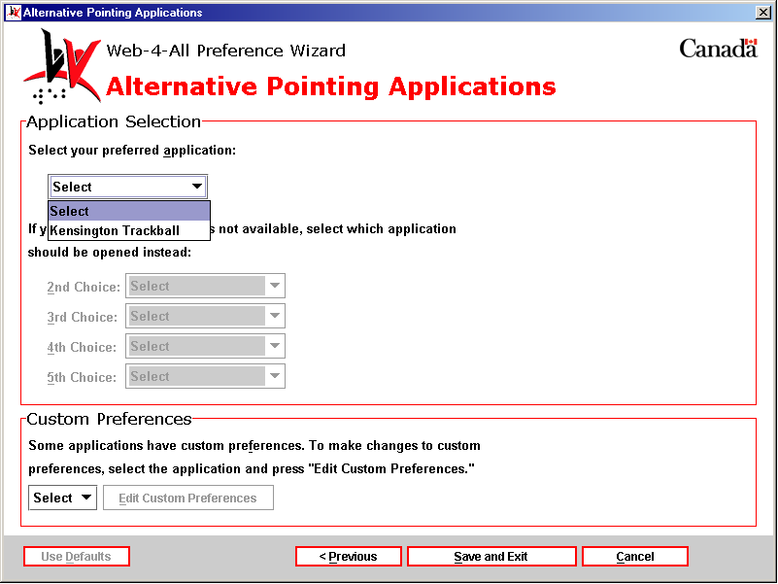

- Custom Preferences – This section enables users to configure the preference settings of any third party application listed on Web-4-All. Use the pull-down menu to choose an application and then select Edit Custom Preferences to access that particular application’s preference settings. These settings are stored on an individual’s Smart Card so that each time Web-4-All launches a favourite third party application those preferences will be automatically loaded along with the program.

I would like an alternative to the standard controls
This section allows clients to replace conventional controls such as an alphanumeric keyboard or mouse with an accessible alternative. This option is especially helpful to those with mobility problems ho have difficulty performing fine motor control movements.

6) “Use voice recognition.” – This option allows users to control the computer via voice activation. Select this checkbox and then “Next” to launch the “Voice Recognition Settings” dialog.

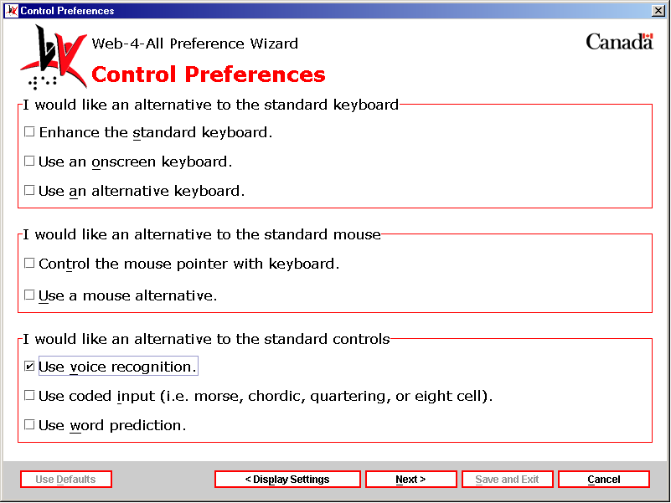

Voice Recognition Settings – This dialog is divided into two sections: General Preferences and Command Control Preferences. Each is described in detail below.

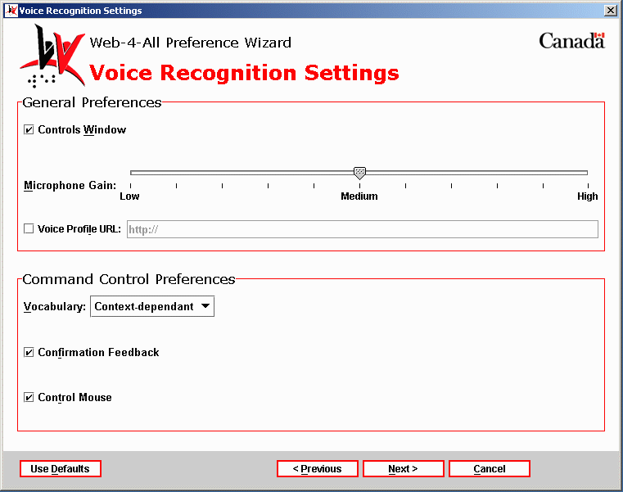

General Preferences – This section provides users with the following three option settings: Controls Window, Microphone Gain, and Voice Profile URL.

- Controls Window: This checkbox allows users to control the current active window verbally through a voice recognition program.
- Microphone Gain: This sliding scale controls microphone gain levels. The scale has three marked settings: Low, Medium (default), and High. The slider pointer snaps to increments between each setting.
- Voice Profile URL: This checkbox allows users to select an external file to configure the voice profile used on the workstation.

Command Control Preferences – This section provides users with the following three options: Vocabulary, Confirmation Feedback, and Control Mouse.

- Vocabulary: This pull-down menu allows users to choose a vocabulary that is either Context-dependent or Natural.

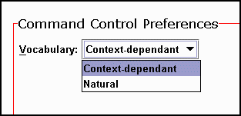

- Confirmation Feedback: When this checkbox is selected, users receive confirmation feedback that an action has been performed.
- Control Mouse: This checkbox enables the user to control the mouse through spoken commands.

Once all selections have been made, select “Next” to advance to the Voice Recognition Applications dialog.

Third Party Applications: The Voice Recognition Applications dialog allows users to establish a third party program as their default screen enhancer. Each time a client’s Smart Card is inserted into a Web-4-All Card Reader, default applications selected by the user will also be launched. Because availability of third party applications varies from workstation to workstation, users can create a list of default screen enhancement applications and organize them in order of preference. For example, if a user’s initial selection is unavailable, Web-4-All will search for, and launch, their second choice, and so on. Up to five third party applications can be selected. Users also have the option of accessing third party preference settings via this dialog.

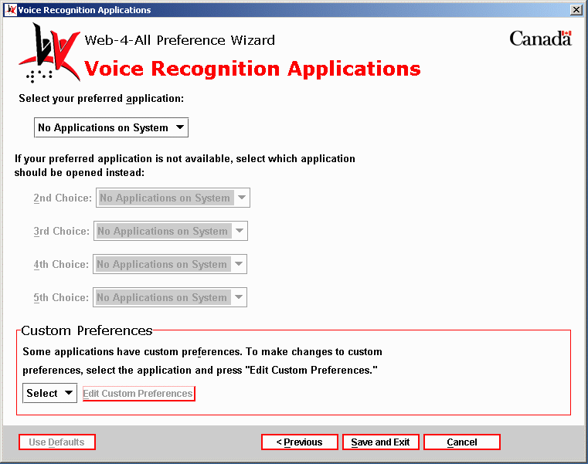

- Custom Preferences – This section enables users to configure the preference settings of any third party application listed on Web-4-All. Use the pull-down menu to choose an application and then select Edit Custom Preferences to access that particular application’s preference settings. These settings are stored on an individual’s Smart Card so that each time Web-4-All launches a favourite third party application those preferences will be automatically loaded along with the program.

7) “Use coded input to control the computer.” – This option allows users to control the computer through coded input (such as Morse code). Select this checkbox and then “Next” to launch the “Coded Input Settings” dialog.

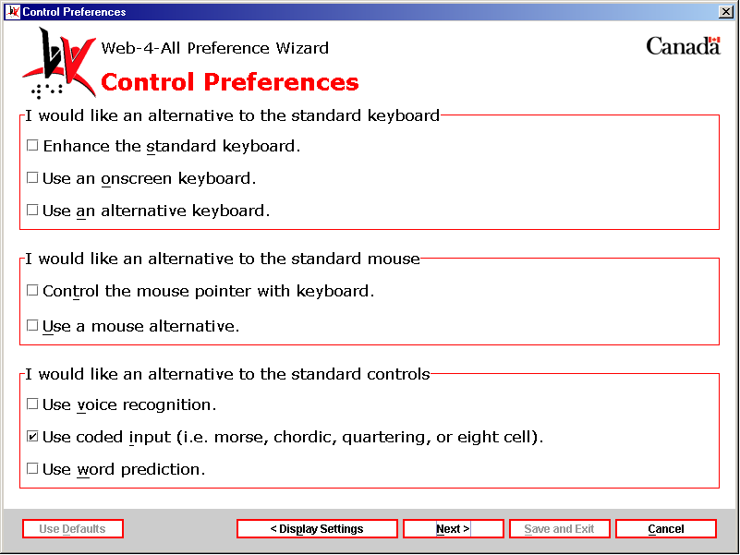

Coded Input Settings – This dialog is comprised of a single section with the following five options: Input Code, Number of Code Switches, Switch Input Type, Timed out code termination and Selection Method. Each option is described in detail below.

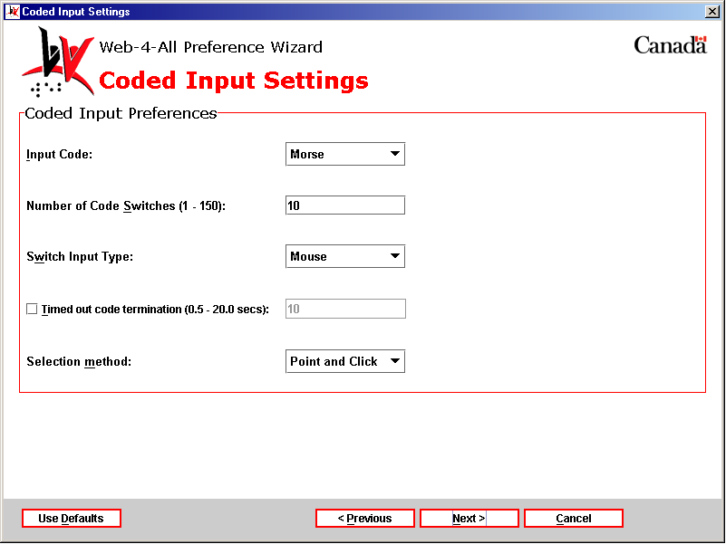

Input Code – A pull-down menu offers users the following options: Morse, Quartering, Eight Cell, and Chordic.

- Morse: Morse code, as an alternative computer input method, transmits code using 1 to 3 switches that are translated into letters, numbers, symbols and commands by the program. Most applications use the standard International Morse Code alphabet and all have additional codes to represent other keys or commands. Many also provide mouse commands. Morse code is especially beneficial to persons with severe physical disabilities because it is requires minimal physical movement and little visual processing of information displayed on the screen. It can be combined with screen enhancers and speech output for those who have difficulty seeing.
- Quartering: This option is used to divide an onscreen keyboard into four quarters or quadrants. First, the user points to the quarter containing the item they wish to select. Then that section of the onscreen keyboard expands to fill the entire keyboard display area and is quartered once again. The process is repeated until the keyboard expands to where a single item is displayed in each quadrant. The user then selects the desired key.
- Eight Cell: This option functions identically to the Quartering except that the onscreen keyboard is divided into eighths rather than quarters.
- Chordic: Chordic keyboards are composed of sets of keys (usually 7 or 8) and are operated using a single hand. The user depressed a combination of keys simultaneously. Different sets of "chords" represent different keystrokes, computer commands, and mouse functions. Chordic keyboards are particularly useful to people with motor disorders affecting one side of the body, amputees, and those with repetitive stress pain.

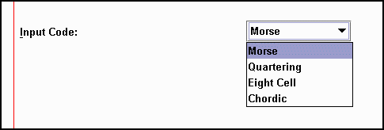

Number of Code Switches (1 – 150): While this entry field accepts values ranging from 1 to 150, the maximum number of switches used to transmit code rarely exceeds 10 (i.e. one switch per finger). In Morse code, for example, the number of switches used is most often between 1 and 3 while Chordic keyboards are usually comprised of 7 or 8 switches.



Switch Input Type: The various switch input types included in this pull-down menu are described in detail in the Switch Input Preferences section on page two of the Onscreen Keyboard Settings with Automatic Scanning chosen as the selection method.

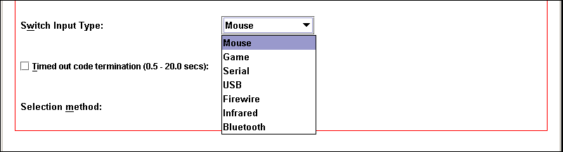

Timed out code termination (0.5 – 20.0 secs): – This entry field determines the length of time for input to be considered complete. For example, if a user enters the code for the letter “A” – dot (*) dash (_) – the pause or delay between the input and when the new letter begins is determined by the timed out code termination line. Accepted values rang from 0.5 to 20 seconds in length.

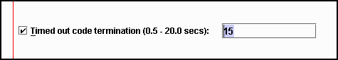

Selection method – This pull-down menu offers clients two selection method options: Point and Click or Point and Dwell.

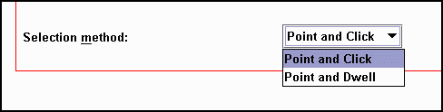

Once all selections have been made, select “Next” to advance to the Coded Input Applications dialog.

Third Party Applications: The Coded Input Applications dialog allows users to establish a third party program as their default screen enhancer. Each time a client’s Smart Card is inserted into a Web-4-All Card Reader, default applications selected by the user will also be launched. Because availability of third party applications varies from workstation to workstation, users can create a list of default screen enhancement applications and organize them in order of preference. For example, if a user’s initial selection is unavailable, Web-4-All will search for, and launch, their second choice, and so on. Up to five third party applications can be selected. Users also have the option of accessing third party preference settings via this dialog.

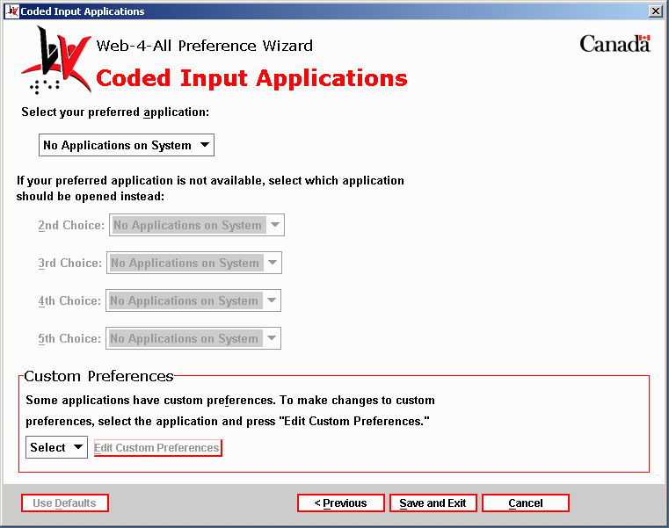

- Custom Preferences – This section enables users to configure the preference settings of any third party application listed on Web-4-All. Use the pull-down menu to choose an application and then select Edit Custom Preferences to access that particular application’s preference settings. These settings are stored on an individual’s Smart Card so that each time Web-4-All launches a favourite third party application those preferences will be automatically loaded along with the program.

8) “Use word prediction.” – This option allows users to type faster and more accurately by generating a list of words based on letters that the user has entered. For example, if a user types the letters “ele” with word prediction turned on, the most frequently used words matching those letters within the context of the sentence will appear in a selectable list. In the example above the list of words might include “elect”, “electricity”, “elect”, “element” and so on. If the user then adds the letter “p” to the entry (i.e. “elep”) then the current list might be replaced by the word “elephant”.

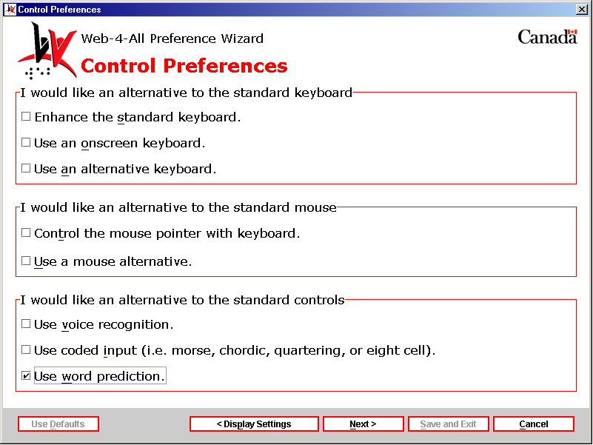

Prediction Settings – This dialog is comprised of a single section with four checkbox options and slider controlling the number of predictions to be displayed. Each option is described in detail below.

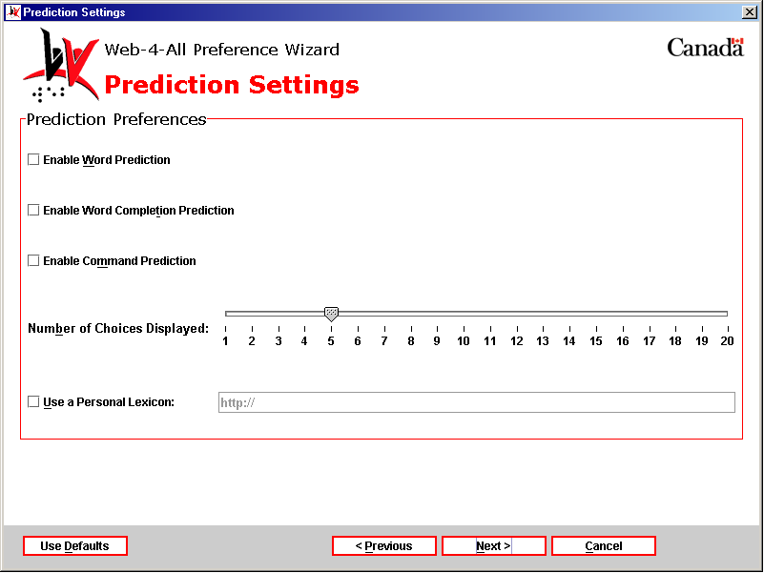

Enable Word Prediction – Selecting this checkbox activates Web-4-All’s word prediction capabilities. This option reduces the number of keystrokes required when typing and also provides online spelling assistance. Word prediction is especially helpful to those with motor impairments and or/learning disabilities. When Enable Word Prediction is activated, Web-4-All monitors the input of a user letter-by-letter, and produces a list of words associated with the letter sequence recorded. Each time a letter is added, the list of words is updated. When the target word appears, the user simply selects it and the word is inserted automatically into their text.

Enable Word Completion Prediction – When this checkbox is enabled, Web-4-All attempts to complete each word as the user types in letters. For example, if a user enters “th”, word completion may attempt to finish the word by adding an “e”. If the user continues typing and enters an “i”, word prediction may attempt to complete the word by adding an “r” (creating the word “their”). Once again, this feature is designed to assist those with motor impairments and/or learning disabilities.

Enable Command Predication – This checkbox option functions similarly to word prediction but, rather than creating a list of dictionary words, this list generates commonly used computer commands (i.e. Open, Save, Print, etc.)

Number of Choices Displayed – This slider controls the number of choices displayed in each list. The scale ranges from one word/command to 20.

Use a Personal Lexicon – Selecting this checkbox allows users to link to their own personal collection of words or vocabulary.

Once all selections have been made, select “Next” to advance to the Prediction Applications dialog.

Third Party Applications: The Prediction Applications dialog allows users to establish a third party program as their default screen enhancer. Each time a client’s Smart Card is inserted into a Web-4-All Card Reader, default applications selected by the user will also be launched. Because availability of third party applications varies from workstation to workstation, users can create a list of default screen enhancement applications and organize them in order of preference. For example, if a user’s initial selection is unavailable, Web-4-All will search for, and launch, their second choice, and so on. Up to five third party applications can be selected. Users also have the option of accessing third party preference settings via this dialog.

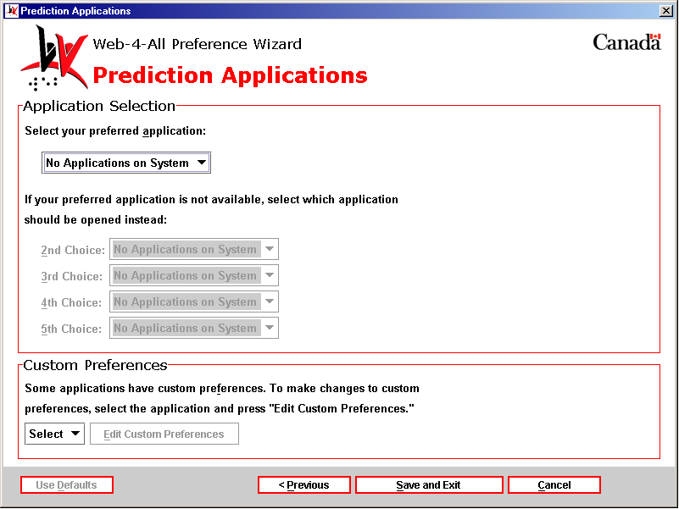

- Custom Preferences – This section enables users to configure the preference settings of any third party application listed on Web-4-All. Use the pull-down menu to choose an application and then select Edit Custom Preferences to access that particular application’s preference settings. These settings are stored on an individual’s Smart Card so that each time Web-4-All launches a favourite third party application those preferences will be automatically loaded along with the program.

Third Party Applications:
Web-4-All currently has seven third party adaptive technology applications integrated into its program. They are: eReader, Home Page Reader (version 3), Kensington Trackball, Opera, Visual Dynamic Keyboard (VDK), Windows Keyboard, and Windows Mouse Keys.

When a third party application is selected from the dropdown menu, clients have the option of launching that particular program’s setup wizard. This enables users to configure their favourite software package to meet their specific needs. It also provides access to additional defaults offered by third party vendors not available in Web-4-All. (Note: If Web-4-All fails to launch a third party application wizard that indicates there are no additional settings associated with the program.)

If two or more third party applications are selected from the dropdown menu, Web-4-All’s “Priority Selector” is launched automatically. The “Priority Selector” enables clients to establish an “order of priority” for the various third party applications.

What follows is a brief description of the various third party applications currently integrated into Web-4-All.

eReader
CAST eReader is a software tool designed to convert text content from a variety of sources (i.e. Web pages, word processing documents, books, newspapers, etc.) into synthesized speech. Users can control reading speed, pitch, modulation and volume through the voice preferences built into eReader.

The application also provides keyboard equivalents for all essential program functions and multiple options for reading, highlighting, and navigating through a document. Voice properties can be optimized for either speed (i.e. for users with a visual impairment) or high quality speech (i.e. for those with learning disabilities who have difficulty interpreting content).

Home Page Reader (Version 3.0)
Home Page Reader (HPR) is a Web page text-to-speech synthesizer designed for computer users who are blind or visually impaired. Users can control the audio presentation in HPR through voice changes, special sound effects, and text tagging. Font size, background and text colour can also be customized.

HPR can speak text, frames, image and text links, alternate text for images and image maps, form elements including JavaScript, graphics descriptions, text in column format, and data input fields. It includes special table navigation features capable of interpreting even the most complex tables and can generate speech for select multimedia applications such as Windows Media Player and Real Player.

Kensington Trackball
Many clients with mobility problems and those who have difficulty performing tasks that require precise motor skills may benefit from using a trackball in place of a standard mouse. As alternative pointing devices, trackballs rely on a large, top-mounted ball to facilitate easy fingertip or mouth-pointer movement and precise control. The trackball’s symmetrical design accommodates both left- and right-handed users and all hand sizes.

Some models include scroll wheels for quick scanning of long documents and web pages and offer custom programmable buttons which can automate repetitive tasks or enable mouth-pointer users to perform drag-n-drop functions.

Opera
The Opera Web browser is renown for its small size, speed, and stability. Opera’s platform-independence makes it easy to be ported to other emerging platforms and simplifies overall maintenance.

This browser does not require extensive system resources to run at an optimum level and, for people concerned about accessibility, Opera adheres to Internet standards as outlined by the World Wide Web Consortium (W3C) guidelines.

Visual Dynamic Keyboard (VDK)
The Visual Dynamic Keyboard (VDK) is an on-screen keyboard that enables clients to control a computer without having to use a standard keyboard or mouse. The VDK appears in a resizable window and provides people with mobility impairments greater access to various Windows applications.

Windows Keyboard
The Windows Operating System (OS) includes built-in accessibility options to make a standard keyboard easier to use. These features include: StickyKeys, FilterKeys, and ToggleKeys.

Select “Settings” and then “Control Panel” from the “Start” menu to access Windows accessibility features.

Select the “Keyboard” tab to access the StickyKeys, FilterKeys, and ToggleKeys options. Users can configure each option to their own specifications by choosing the “Settings…” button beside each checkbox.

Keyboard

“Use StickyKeys” – The Windows Keyboard “Use StickyKeys” option enables individuals who have difficulty performing multiple keystrokes to use the Shift, Ctrl and Alt keys as modifiers. If the user depresses any of these modifier keys when the “Use StickyKeys” checkbox is selected, the computer considers that key to be “held down” until another keystroke is completed.

“Use FilterKeys” – When the “Use FilterKeys” checkbox is selected, clients can direct Windows to ignore brief or repeated keystrokes and increase the length of time a key must be held down before it is considered a legitimate keystroke.

“ToggleKeys” – The “ToggleKeys” option generates a tone when a user depresses the Caps Lock, Num Lock, or Scroll Lock keys.

Sound
Selecting the “Sound” tab from the Accessibility Properties dialog provides users with the option of having Windows display a visual warning whenever their system generates a sound. Users can also choose to have Windows instruct programs to display captions for speech or sounds.

Display
The “Display” tab enables users to optimize the contrast of background colours and text on their computer system. This option also allows users to set the blink rate and width of the cursor.

MouseKeys
When the “Mouse” tab is selected from the “Accessibility Properties” dialog, settings for the MouseKeys are displayed. (Windows MouseKeys are explained in detail in a separate section below.)

General
The “General” tab option allows users to turn off accessibility features if the computer remains idle for a specified time. Other options include providing a visual and/or audio warning when an accessibility feature is being toggled on or off.

Windows MouseKeys
Windows MouseKeys allow users to control mouse pointer movement via the numeric keypad. The number 5 key functions as the left mouse button while the keys directly above (8), below (2), to the left (4), and right (6) of this central key are used to control vertical and horizontal mouse pointer movement. The 7, 9, 1, and 3 keys move the mouse pointer diagonally.

The “Settings” for the MouseKeys enable users to set pointer speed and acceleration through two separate sliding scales. Clients also have the option of using the Ctrl and Shift keys to increase and decrease pointer speed and the Num Lock key can be used to toggle the Mouse Keypad on and off. In addition, clients can choose to have MouseKey status displayed on-screen and create a Keyboard shortcut using the Left Alt + Left Shift + Num Lock keys.

Acknowledgements:

Web-4-All includes software developed by the Apache Software Foundation (http://www.apache.org/). To view the organization’s licensing agreement in its entirety, please see the Appendix section below.

Third Party Applications:

CAST eReader – Copyright © CAST, All Rights Reserved
30 Cross St., Peabody, MA 01960 U.S.A.
Telephone: (978) 531-8555,
Email: cast@cast.org

Home Page Reader – Copyright © IBM Corporation, All Rights Reserved
1133 Westchester Ave., White Plains, NY 10604 U.S.A.
Telephone: (800)IBM-4You, TTY service: 1-(800)IBM-3383 (North America only)

JAWS® for Windows® – Copyright © Freedom Scientific Inc., All Rights Reserved
11800 31st Court N., St. Petersburg, FL 33716 U.S.A.
Telephone: (727) 803-8000, 1-(800) 444-4443
Email: Info@FreedomScientific.com

Kensington Trackball – Copyright © Kensington Technology Group, All Rights Reserved
2000 Alameda de las Pulgas, 2nd Floor, San Mateo, CA 94403-1289 U.S.A.
Telephone: (650) 572-2700, Fax: (650) 572-9675

Opera Web browser – Copyright © Opera Software, All Rights Reserved
P.O. Box 2648 St. Hanshaugen, NO-0131 Oslo, Norway
Telephone: +47 24 16 40 00, Fax: +47 24 16 40 01
Email: general@opera.com.

Windows Keyboard/Windows MouseKeys – Copyright © Microsoft Corporation, All Rights Reserved
One Microsoft Way, WA 98052-6399 U.S.A
Telephone: (425) 882-8080

Appendix:

The Apache Software License, Version 1.1
Copyright (c) 1999-2000 The Apache Software Foundation. All rights reserved.

Redistribution and use in source and binary forms, with or without modification, are permitted provided that the following conditions are met:
1. Redistributions of source code must retain the above copyright notice, this list of conditions and the following disclaimer.

2. Redistributions in binary form must reproduce the above copyright notice, this list of conditions and the following disclaimer in the documentation and/or other materials provided with the distribution.

3. The end-user documentation included with the redistribution, if any, must include the following acknowledgment: "This product includes software developed by the Apache Software Foundation (http://www.apache.org/)." Alternately, this acknowledgment may appear in the software itself, if and wherever such third-party acknowledgments normally appear.

4. The names "Xerces" and "Apache Software Foundation" must not be used to endorse or promote products derived from this software without prior written permission. For written permission, please contact apache@apache.org.

5. Products derived from this software may not be called "Apache", nor may "Apache" appear in their name, without prior written permission of the Apache Software Foundation.

THIS SOFTWARE IS PROVIDED “AS IS” AND ANY EXPRESSED OR IMPLIED WARRANTIES, INCLUDING, BUT NOT LIMITED TO, THE IMPLIED WARRANTIES OF MERCHANTABILITY AND FITNESS FOR A PARTICULAR PURPOSE ARE DISCLAIMED. IN NO EVENT SHALL THE APACHE SOFTWARE FOUNDATION OR ITS CONTRIBUTORS BE LIABLE FOR ANY DIRECT, INDIRECT, INCIDENTAL, SPECIAL, EXEMPLARY, OR CONSEQUENTIAL DAMAGES (INCLUDING, BUT NOT LIMITED TO, PROCUREMENT OF SUBSTITUTE GOODS OR SERVICES; LOSS OF USE, DATA, OR PROFITS; OR BUSINESS INTERRUPTION) HOWEVER CAUSED AND ON ANY THEORY OF LIABILITY, WHETHER IN CONTRACT, STRICT LIABILITY, OR TORT (INCLUDING NEGLIGENCE OR OTHERWISE) ARISING IN ANY WAY OUT OF THE USE OF THIS SOFTWARE, EVEN IF ADVISED OF THE POSSIBILITY OF SUCH DAMAGE.

This software consists of voluntary contributions made by many individuals on behalf of the Apache Software Foundation and was originally based on software copyright (c) 1999, International Business Machines, Inc., http://www.ibm.com. For more information on the Apache Software Foundation, please see http://www.apache.org/.

